

**What is LITI-GATE?**

LITI-GATE is a group of organizations that work together to protect the rights of people with intellectual and/or psychosocial disabilities.

**Which organisations work on the project?**

* Validity Foundation from Hungary.
* European Network on Independent Living (ENIL) from Belgium.
* Centre for Legal Resources (CLR/CRJ) from Romania.
* Forum for Human Rights (FORUM) from the Czech Republic.
* Kera Foundation (KERA) from Bulgaria.
* Victim Support Europe (VSE) from Belgium.

**What is the purpose of LITI-GATE?**

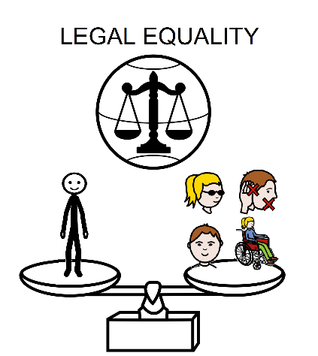The main goal of LITI-GATE is that people with disabilities have the same rights in the European Union as everybody else.

A right is something that you are allowed to do or have,

just because you're a person.

National laws must guarantee rights for people with disabilities.

We will use “strategic litigation” to defend rights at the European Court.

When a right is not respected, we need a lawyer.

A lawyer is a legal expert that helps people to defend their rights.

In “strategic litigation”, a lawyer can ask the European Court for help.

The European Court can ask the country to change the national law to be fair

so that the rights of people with disabilities are respected.

Courts and rights are difficult to understand.

We want to make accessible documents

to help people with disabilities defend their rights in Court.

**How will LITI-GATE achieve its goal?**

LITI-GATE will achieve its goal by doing four main tasks:

1. We will do research. We will hear about the experiences of people with disabilities and lawyers in Courts.
2. 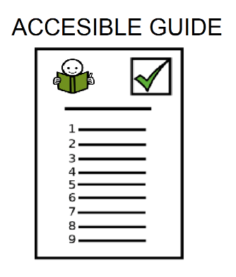We will create an accessible guide and materials for people with disabilities. This guide will help People with disabilities to:
   * access justice.
   * access support services to understand what happens in Court.
3. A group of people in a classroom

   Description automatically generatedWe will offer training for lawyers, prosecutors and judges

so they know the needs of people with disabilities.

1. We will do activities to make people aware of

the importance of defending the rights of

people with disabilities.

**How long is the LITI-GATE project?**

The LITI-GATE project is two years long, from September 2023 to June 2025.

**Who finances the LITI-GATE project?**

The European Education and Culture Executive agency of the European Commission.

**How can I participate?**

You can tell us about your experience in Court.

We will help you during the interview.

We will provide support so you can participate.

**Who can I contact if I want more information about the project?**

If you have any project-related questions, you can contact **Inês Nunes De Freitas** at: [*i.nunesdefreitas@victimsupporteurope.eu*](mailto:i.nunesdefreitas@victimsupporteurope.eu)*.*

*The pictographic symbols used are property of the Government of Aragon (Spain) and have been created by Sergio Palao for ARASAAC (*[*http://www.arasaac.org*](http://www.arasaac.org)*), which distributes them under Creative Commons License BY-NC-SA.*