**Stop subsidising sheltered employment: Implementing the UN CRPD into EU State Aid legislation**

***Briefing by the European Network on Independent Living, November 2024***

# Easy-to-read Summary

1. Introduction

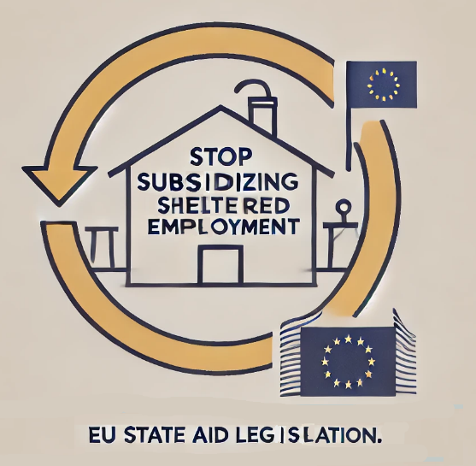

The European Network on Independent Living (ENIL) has found that public funds are often used to finance segregated environments for people with disabilities in the EU, you can see segregated environments.

For example institutions and sheltered workshops.

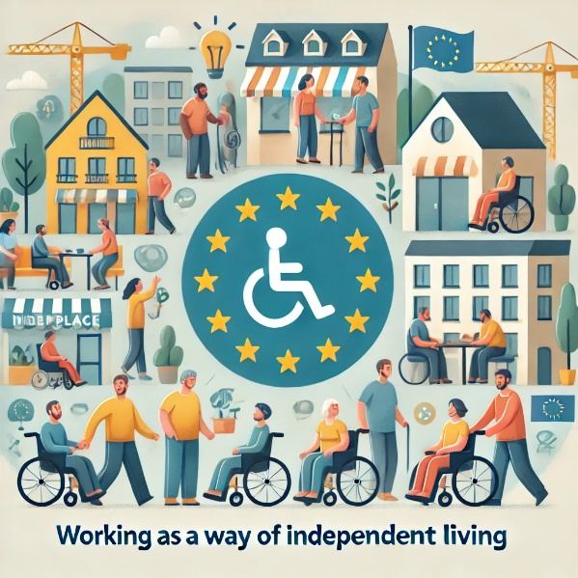

This funding prevents people with disabilities from being fully included in society and requires a large amount of money.

1. The Problem with Sheltered Employment

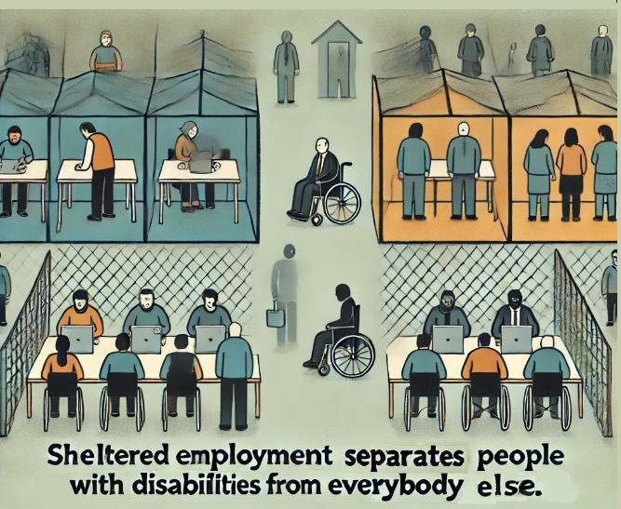Sheltered employment is presented as a way to integrate people with disabilities into regular work.

However, studies and real-life examples show that this claim is incorrect.

Instead of helping, sheltered employment can actually make it harder for people with disabilities to get real jobs.

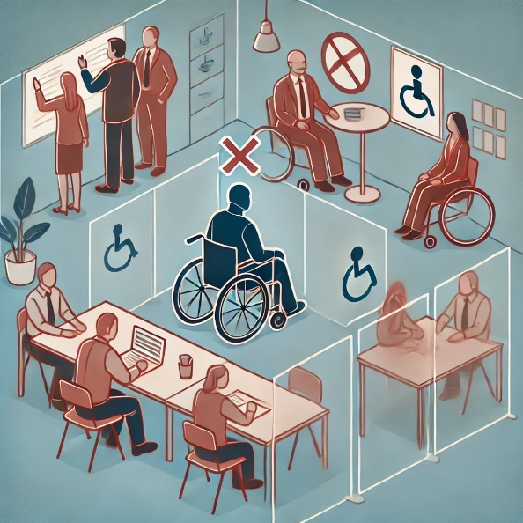

According to the UN's General Comment No. 8, sheltered employment promotes prejudice, and discrimination.

1. **Examples of Subsidising segregated services**

Governments in countries like Germany, Sweden, and Spain spend millions of euros on institutions and sheltered workshops for people with disabilities.

For example:

* In Sweden, the government supports Samhall, a sheltered employment provider, with €500 million per year.
* In Germany, various regional governments fund the construction and maintenance of sheltered workshops.
* In Spain, the government funds facilities like sheltered workshops in Navarra and Andalucía.

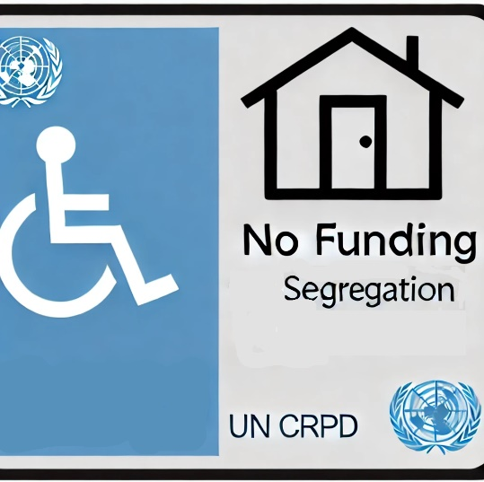The UN Convention on the Rights of Persons with Disabilities (CRPD) requires governments to stop funding these segregating services.

It supports the right of people with disabilities to live independently in the community.

1. **Proposal for Change in EU Legislation**

EU rules on state aid provide an opportunity to change how disability services are funded.

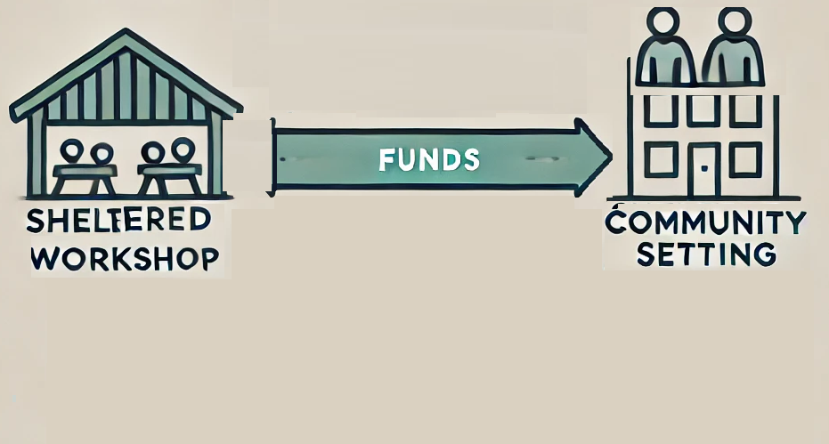

ENIL proposes that subsidies should no longer go to services that segregate people with disabilities.

Instead, resources should be directed to support services that help people with disabilities live in the community and work in regular jobs.

1. **The UN CRPD and the End of Segregated Services**

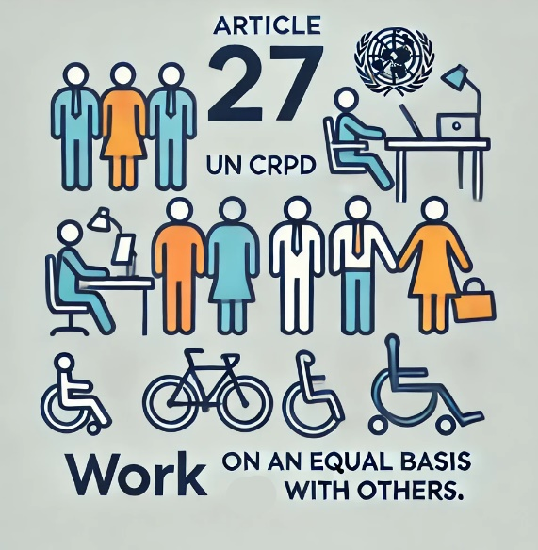

The CRPD promotes inclusion and requires that people with disabilities have the same work opportunities as others.

Article 27 recognizes the right of people with disabilities to work on equal terms.

Sheltered workshops do not meet this standard because they isolate people, pay lower wages, and do not offer regular employment contracts.

Additionally, Article 19 of the CRPD states that people with disabilities have the right to live independently in the community, and resources should be moved from institutions to community-based services.

1. **EU State Aid and Proposed Reform**

EU rules allow governments to subsidize social services, but ENIL suggests that these rules should only support services that align with human rights.

To achieve this:

* 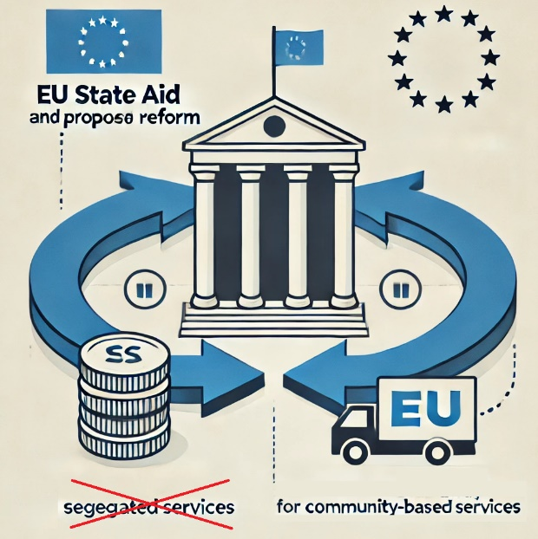Article 34, Section 2(f) of the General Block Exemption Regulation (GBER)  
  should be removed.  
  This would make it harder for authorities  
  to fund segregating services.
* Resources saved could then support accessible, person-centered services, and inclusion in the open labour market.

The current GBER is valid until December 31, 2026, giving the EU time to make these changes.

# Introduction

The European Network on Independent Living has [realised a case study](https://enil.eu/enil-case-study-finds-state-aid-to-be-important-in-funding-institutions/) which showed that public subsidies play an important role in the financing of segregated settings for persons with disabilities, like institution, sheltered workshops and others in the EU. There is evidence that regional and local authorities subsidise disability services which are blocking the inclusion of disabled persons and this with substantial financial resources.

Sheltered employment is justified by its alleged quality to integrate disabled people into regular work. [Individual cases](https://enil.eu/avoiding-the-sheltered-employment-trap/) and [academic studies](https://journals.sagepub.com/doi/full/10.1177/09589287211002435) provide evidence, that this claim is not correct. It appears to be the case that sheltered employment creates a barrier for disabled people to find proper work. [General Comment No 8](https://www.ohchr.org/en/documents/general-comments-and-recommendations/crpdcgc8-general-comment-no-8-2022-right-persons) on the rights of persons with disabilities to work and employment stated that sheltered employment is underpinned by “social prejudice, inequality and discrimination”.

The ENIL study present several concrete cases. From 1956 until the present day the private, non-profit providers of social services in the northern German state of Lower Saxony have been receiving EUR 20 million per year from the budget of the regional government. Those service providers run many institutions and sheltered workshops for disabled people. In 2011, authorities in the Land of Rheinland-Pfalz paid EUR 5,5 million to a private provider to convert an abandoned hospital into an institution. In 2009, authorities in northern Portugal financed the construction of a long-term mental health unit with a contribution of EUR 2 million.[1] It can be assumed that such practices are common in all EU member states.

The EU and all Member States are state parties to the [United Nations Convention on the Rights of Persons with Disabilities](https://www.ohchr.org/en/instruments-mechanisms/instruments/convention-rights-persons-disabilities) (UN CRPD). The UN CRPD obliges state parties to stop the financing of institutions. EU Member States have an obligation to ensure that all disabled people can live independently in the community. In addition, the right to work in the regular labour market must be promoted.

The chapter of the Treaty on the Functioning of the EU (TFEU) on state aid allows to regulate the way national, regional and local authorities subsidise for-profit and non-profit undertakings, including providers of social services.

* Could those competences be used to change the way disability services are financed?
* Shouldn’t the EU and the Member States commit their financing to respect all human rights and eliminate any type of discrimination persons with disabilities face?
* Could reforms of the EU state aid regulations restrict the subsidies flowing into services which segregate but, instead increase the resources available for person-centred services and the inclusion of disabled people into the regular labour market?

The UN CRPD emphasises the importance of mainstreaming disability issues and obliges state parties to refrain from engaging in any act or practice that is inconsistent with the Convention.´

The present briefing will add additional evidence on the practice of subsidizing segregating services, by presenting further cases. The cases are mostly from Sweden, Germany and Spain. Many more exist but due to lack of data collection and resources for research it's not evident based yet. It will then review the relevant provisions under the UN CRPD. it will also outline key provisions of EU State Aid legislation and discuss possible changes that might help redirect funding towards community-based services and the role you can play making inclusion a reality for every single person with a disability regardless of the needed support.

# Cases of subsidisation of segregating services

1. **Sweden**

* The Swedish government [is subsidising](https://ec.europa.eu/competition/state_aid/cases/270893/270893_1951044_95_4.pdf) the provider of sheltered employment Samhall Aktiebolag with EUR 500 million per year. Samhall is employing 19 135 disabled people.

1. **Germany**

* [The government of Saxony](https://www.mdr.de/nachrichten/sachsen/chemnitz/vogtland/lebenshilfe-reichenbach-foerdermittel-werkstatt-vogtland-100.html) is subsidising the construction of a sheltered workshop for 160 disabled people with EUR 6,8 million. The non-profit organisation Lebenshilfe Rheichenbach will be running the workshop.
* [The government of Bavaria](https://www.stmas.bayern.de/aktuelle-meldungen/pm2411-284.php) is the subsidising the renovation of a sheltered workshop in Burgkunstadt for 140 disabled people with EUR 2,93 million. The non-profit organisation Werkstätten St. Joseph Burgkunstadt gGmbH is running the workshop.
* [The government of Bavaria](https://www.bayern.de/12-millionen-euro-fuer-werkstattplaetze-fuer-menschen-mit-behinderung-in-augsburg-in-schwaben-menschen-mit-behinderung/) is subsidising the construction of a sheltered workshop with EUR 1,2 million. The non-profit Caritas Augsburg will be running the workshop.
* [The government of Bavaria](https://www.bayern.de/55-millionen-euro-fuer-werkstatt-und-foerderstaette-der-wertach-werkstaetten-gmbh-in-kaufbeuren-in-schwaben-menschen-mit-behinderung/) is subsidising the construction of a sheltered workshop for 36 disabled people with EUR 5,5 million. The workshop will be run by the company Werkstätten GmbH Kaufbeueren in Schwaben.
* [The government of Bavaria](https://www.bayern.de/106-millionen-euro-fuer-240-werkstattplaetze-fuer-menschen-mit-behinderung-in-bischofsmais-menschen-mit-behinderung/) is subsidising the construction of a sheltered workshop for 240 disabled people with EUR 10,6 million. The non-profit Lebenshilfe Deggendorf will be running the workshop.
* [The government of Bavaria](https://www.bayern.de/655-000-euro-fuer-den-erweiterungsbau-einer-foerderstaette-in-schweinspoint-in-schwaben-menschen-mit-behinderung/) is subsidising the construction of a sheltered workshop for 28 disabled people with EUR 655 000. The non-profit Förderstätte Schweinspoint will be running the workshop.
* [The government of Bavaria](https://www.bayern.de/2-millionen-euro-fuer-den-bau-von-20-foerderstaettenplaetzen-in-eggenfelden-in-niederbayern-menschen-mit-behinderung/) is subsidising the construction of a sheltered workshop for 20 disabled people with EUR 2 million. The non-profit Eggenfeldener workshops St. Rupert will be running the workshop.
* [The government of Bavaria](https://www.stmas.bayern.de/aktuelle-meldungen/pm2409-234.php) is subsidising the renovation of the Moritzberg workshop in Laut-Schönberg with EUR 761 500.
* [The government of Hessen and the City of Kassel](https://www.kassel.de/aktuelles/aktuelle-meldungen/foerdermittelbescheid.php) are financing the construction and renovation of a sheltered workshop for 140 disabled people with EUR 2,9 million.

1. **Spain**

* [The government of Navarra](https://www.navarra.es/es/-/nota-prensa/el-gobierno-de-navarra-invertira-16-2-millones-en-la-gestion-de-dos-centros-de-aspace-navarra-que-atienden-a-132-personas-con-discapacidad) is financing institutions with a budget of EUR 16,2 million. Places for 132 disabled people will be created. The organisation Aspace Navarra will be running the facility.

- [The government of Andalucia](https://www.juntadeandalucia.es/agenciadeserviciossocialesydependencia/index.php/component/k2/item/165-loles-lopez-inaugura-la-nueva-residencia-de-asprogrades-que-ha-contado-con-cuatro-millones-de-inversion) is financing the construction of an institutions with EUR 3,9 million. Places for 30 disabled people will be created. The organisation Asprogrades will be running the facility.

Desk research and information provided by ENIL members has made it possible to trace the subsidisation of services for disabled people which are segregating and discriminatory. National, regional and local authorities are spending EUR 553,43 million on the projects listed above.

# The UN CRPD and the end of segregating services

The UN CRPD and the General Comments oblige state parties to discontinue sheltered workshops and institutions.

Article 27 of the UN CRPD states that “State Parties recognise the right of persons with disabilities to work, on an equal basis with others”. General Comment No 8 on employment clarified that “segregated employment for persons with disabilities, such as sheltered workshops, is not to be considered as a measure of progressive realisation of the right to work, which is evidenced only in employment that is freely chosen or accepted and performed in an open and inclusive labour market”. State parties should “facilitate the transition away from segregated work environments for persons with disabilities and support their engagement in the open labour market”.

The General Comment outlined the following defining criteria of sheltered workshops:

* Persons with disabilities are segregated, away from open, inclusive and accessible employment;
* Employment is organised around certain specific activities that persons with disabilities are deemed to be able to carry out;
* The medical and rehabilitation approaches to disability are focused on and emphasised;
* Transition to the open labour market is not effectively promoted;
* Persons with disabilities do not receive equal remuneration for work of equal value;
* Persons with disabilities are not remunerated for their work on an equal basis with others;
* Persons with disabilities do not usually have regular employment contracts and are therefore not covered by social security systems.

Article 19 of the UN CRPD establishes the obligation of state parties to recognise the right of disabled people to live independently. General Comment No 5 clarified that support services must not be provided in institutions but through person-centred services. No new institutions shall be built and existing institutions must not be renovated. Financial resources need to be redirected from institutions to community-based services.

Article 4, paragraph a of the UN CRPD obliges state parties to “undertake all appropriate legislative, administrative measures for the implementation of the rights recognised in the present convention”. Paragraph d adds that countries shall “refrain from engaging in any act or practice that is inconsistent with the present Convention”.

The European Strategy on the Rights of Persons with Disabilities strives to mainstream disability throughout all policy area. Employment is one of the priorities of the Strategy: “More needs to be done to ensure better labour market outcomes for persons with disabilities”.

# EU State Aid legislation and the reform of subsidisation

Subsidies granted by national, regional or local authorities to individual undertakings might affect the internal market. Thus, Articles 107 to 109 of the Treaty on the Functioning of the EU grant the Union the competence to review, abolish or alter financial aid provided, if it meets certain criteria.

Europe’s Social Service Providers [have been arguing](https://www.socialserviceseurope.eu/_files/ugd/9f45fc_6856169a5aa041849b394e35744ff988.pdf) for a long time that competition rules must not be the only criterion to decide whether financial support to an undertaking is permissible, if such aid is given to social services. Free markets are unable to ensure social services are offered at a price that is affordable for everyone throughout the entire EU. This stance deserves unequivocal support.

The European Union has, to a certain extent, accepted this argumentation.

At this point, it is important to recall Article 26 of the [Charter of Fundamental Rights of the European Union](https://eur-lex.europa.eu/legalcontent/EN/TXT/?uri=CELEX%3A12012P%2FTXT) which states that “[t]he Union recognises and respects the right of persons with disabilities to benefit from measures designed to ensure their independence, social and occupational integration and participation in the life of the community.” Article 21 of the Charter prohibits discrimination on any ground, including disability.[2] EU State Aid competences are stemming from primary law. However, the Charter of Fundamental Rights has the status of primary law too.

**Services of General Economic Interest**

The [decision of the European Commission](https://eur-lex.europa.eu/legal-content/EN/TXT/PDF/?uri=CELEX:32012D0021) of 20 December 2011 outlines under which conditions financial aid in the form of public service compensations granted to services of general economic interest is permissible. Social services can be regarded as services of general economic interest if they offer “clearly identified services, meeting social needs as regards health and long-term care, childcare, access to and reintegration into the labour market, social housing and the care and inclusion of vulnerable groups”.

This rule deserves support, as long as it does not contradict legal obligations stemming from other laws and conventions, like the UN CRPD. Services which are not in line with the UN CRPD should not be regarded as services of general economic interest.

**The General Block Exemption Regulation (GBER)**

The [regulation of the European Commission No 651 of 17 June 2014](https://eur-lex.europa.eu/EN/legal-content/summary/general-block-exemption-regulation.html) declared certain categories of aid compatible with the internal market.

Section 6 “Aid for disadvantaged workers and for workers with disabilities” allows authorities to financially support undertakings which employ disabled people. Expenditures for wages, additional costs of employment or costs of assistance can be subsidised. This rule is supportive of the UN CRPD objective to ensure access to the regular labour market.

However, article 34, paragraph 2, section f, states: “The eligible costs shall be the following: …where the beneficiary provides sheltered employment, the costs of constructing, installing or modernising the production units of the undertaking concerned, and any costs of administration and transport, provided that such costs result directly from the employment of workers with disabilities”.

Thus article 34, 2, f allows authorities to financially support sheltered workshops, which is not aligned with the UN CRPD.

**Potential for reform**

The European Unions´ competences on state aid, provides a possible pathway to restricting or altogether stopping the practice of subsiding sheltered employment. The should EU accept that sheltered workshops are not services of general economic interest, because they are not in line with the EU Treaties and the UN CRPD. Thus, the option of providing financing to sheltered employment should be removed from the General Block Exemption Regulation (GBER). Once this is done, the EU will be obliged to enforce the rule. It would become possible to make cases of non-compliance the subject of judicial investigations and even take them to court.

The GBER already provides authorities with the option to finance measures which are more effective of including disabled people into proper employment, for example wage contributions, assistance at work or compensations for the costs of reasonable accommodations. If the considerable subsidies into sheltered employment were to disappear, there would be significant more resources available to finance those options.

At the moment, the GBER makes it easy for authorities to subsidise sheltered employment. According to the article 59 of the GBER, the legislation will apply until 31 December 2026. A renewed regulation will have to be drafted until then. That is an opportunity for reform. ENIL is in favour of using this opportunity to change the regulation so it will be significantly harder for authorities to subsidise sheltered employment.

The removal of article 34, 2, f should make it more difficult for authorities to finance sheltered workshops and make more financial resources available to integrate disabled people into the regular labour market. The following amendment is proposed:

# Potential for reform

According to the article 59 of the GBER, the regulation will apply until 31 December 2026. A renewed regulation will have to be drafted until then.

The removal of article 34, 2, f should make it more difficult for authorities to finance sheltered workshops and make more financial resources available to integrate disabled people into the regular labour market. The following amendment is proposed:

|  |  |
| --- | --- |
| Section 6  Aid for disadvantaged workers and for workers with disabilities  Article 34  Aid for compensation the additional costs of employing workers with disabilities | |
| 1. Aid for compensating the additional costs of employing workers with disabilities shall be compatible with the internal market within the meaning of Article 107(3) of the Treaty and shall be exempted from the  notification requirement of Article 108(3) of the Treaty, provided the conditions laid down in this Article and in Chapter I are fulfilled  2. The eligible costs shall be the following:   1. costs of adapting the premises; 2. costs of employing staff solely for time spent on the assistance of the workers with disabilities and of training such staff to assist workers with disabilities; 3. costs of adapting or acquiring equipment, or acquiring and validating software for use by workers with disabilities, including adapted or assistive technology facilities, which are additional to those which the beneficiary would have incurred had it employed workers who are not workers with disabilities; 4. costs directly linked to transport of workers with disabilities to the working place and for work related activities; 5. wage costs for the hours spent by a worker with disabilities on rehabilitation   ~~(f) where the beneficiary provides sheltered employment, the costs of constructing, installing or modernising the production units of the undertaking concerned, and any costs of administration and transport, provided that such costs result directly from the employment of workers with disabilities.~~ | 1. Aid for compensating the additional costs of employing workers with disabilities shall be compatible with the internal market within the meaning of Article 107(3) of the Treaty and shall be exempted from the  notification requirement of Article 108(3) of the Treaty, provided the conditions laid down in this Article and in Chapter I are fulfilled  2. The eligible costs shall be the following:   1. costs of adapting the premises; 2. costs of employing staff solely for time spent on the assistance of the workers with disabilities and of training such staff to assist workers with disabilities; 3. costs of adapting or acquiring equipment, or acquiring and validating software for use by workers with disabilities, including adapted or assistive technology facilities, which are additional to those which the beneficiary would have incurred had it employed workers who are not workers with disabilities; 4. costs directly linked to transport of workers with disabilities to the working place and for work related activities; 5. wage costs for the hours spent by a worker with disabilities on rehabilitation |

# Conclusion

The present briefing advances a concrete proposal for reform, a first step to bring EU State Aid legislation into line with the UN CRPD. Of course, there are more regulations which constitute the relevant acquis. However, the date for the review of the General Block Exemption Regulation is the closest to the present date. Proposals for the reform of other State Aid Regulations should be advanced, once those legislations are up for review.

Brussels the 12th of November 2024

Queries about this document are to be directed to:

Florian Sanden, ENIL Policy-Coordinator

[florian.sanden@enil.eu](mailto:florian.sanden@enil.eu)

**ENIL Brussels Office vzw/asbl**  
Mundo J - 6th Floor  
Rue de l’Industrie 10  
1000 Brussels  
Belgium

Phone (office): 00 32 2 893 25 83

## About the European Network on Independent Living

Ein Bild, das Text, Schrift, Logo, Marke enthält.
The European Network on Independent Living (ENIL) is a Europe-wide network of disabled people, with members throughout Europe. ENIL is a forum for all disabled people, Independent Living organisations and their non-disabled allies on the issues of Independent Living. ENIL represents the disability movement for human rights and social inclusion based on solidarity, peer support, deinstitutionalisation, democracy, self-representation, cross disability and self-determination. For more information, see: www.enil.eu

*Co-funded by the European Union. Views and opinions expressed are however those of the author(s) only and do not necessarily reflect those of the European Union or the European Commission. Neither the European Union nor the granting authority can be held responsible for them.*

1. Portugal ratified the UN CRPD in 2009: <https://www.ohchr.org/en/treaty-bodies/crpd/portugal-imm-situation>
2. Charter of Fundamental Rights of the European Union (2012), available at