# Easy-to-Read Survey for ENIL Strategic Plan

This survey is about ENIL’s plans for the future.

We want to know what you think.

Your answers will help us.

After you answer the questions, please send this document by e-mail to Kamil Goungor.

His e-mail address is [kamil.goungor@enil.eu](mailto:kamil.goungor@enil.eu).

## Section 1: About You

### 1. Are you answering for yourself or an organization?

### Select one adding an X on the box:

* Organization (full ENIL member)
* Organization (associated ENIL member)
* Individual member (full)
* Individual member (associated)
* ENIL Youth Network

**2. What country do you live in?**

**Write your answer below:**

- _________________

### 3. How long have you been part of ENIL?

### Select one adding an X on the box:

- Less than 1 year

- 1 to 5 years

- 6 to 10 years

- More than 11 years

## Section 2: ENIL’s Vision

ENIL wants Europe to be a place where all disabled people:  
- Can make choices about their lives.  
- Are respected and included in the community.  
- Enjoy their human rights.

### 4. Do you think ENIL’s vision is good?

### Select one adding an X on the box:

- Yes

- No

- Not sure

### 

### 5. What would you add or change?

### Write your answer below:

___________________________________________________________________________________________________________________________________________________________________________________________________________________________________________________________________________________

## Section 3: Important Topics

### 6. Which topics are most important for ENIL?

### Select 4 adding an X on the box:

- Personal assistance

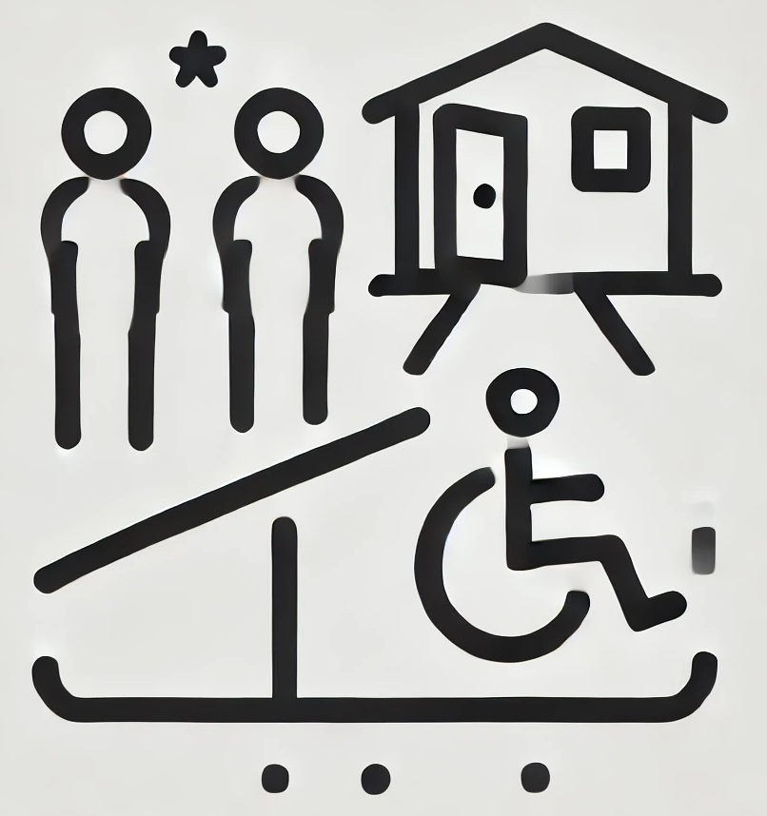 - Communication support

- Social and political participation

- Access to buildings and spaces

 - Education and learning

- Transport

- Advocacy

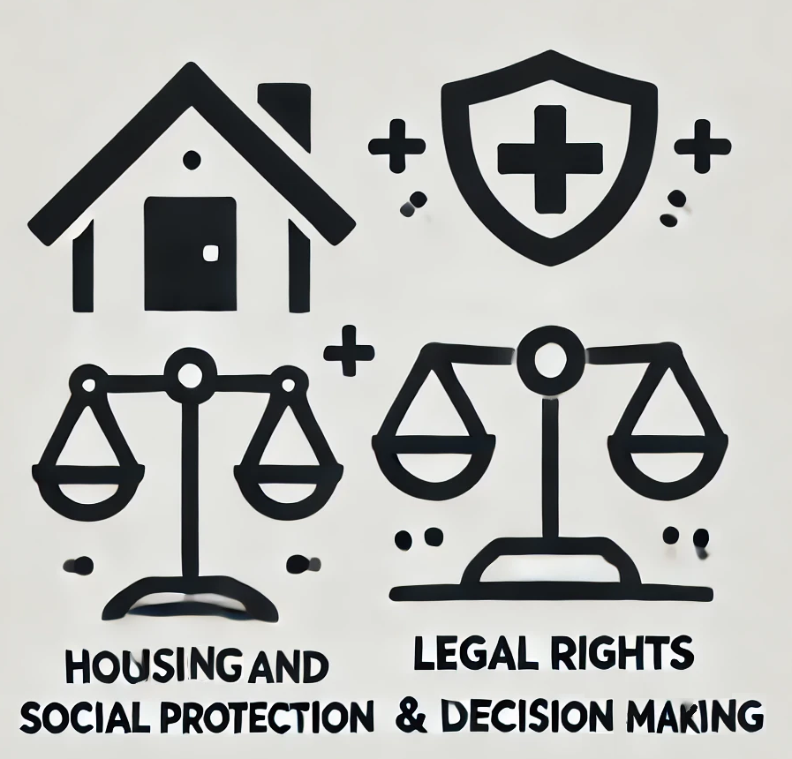 - Housing

- Benefits and social protection

 - Legal rights and decision-making

- Information

- Peer support

 - Work and jobs

- Healthcare

- Technology and aids

## Section 4: Your Ideas

### 7. Is there anything else you want to tell us about ENIL’s plans?

____________________________________________________________________________________________________________________________________________________________________________________________________________________________________________________________________________________________________________________________________________

________________________________________________________________________________________