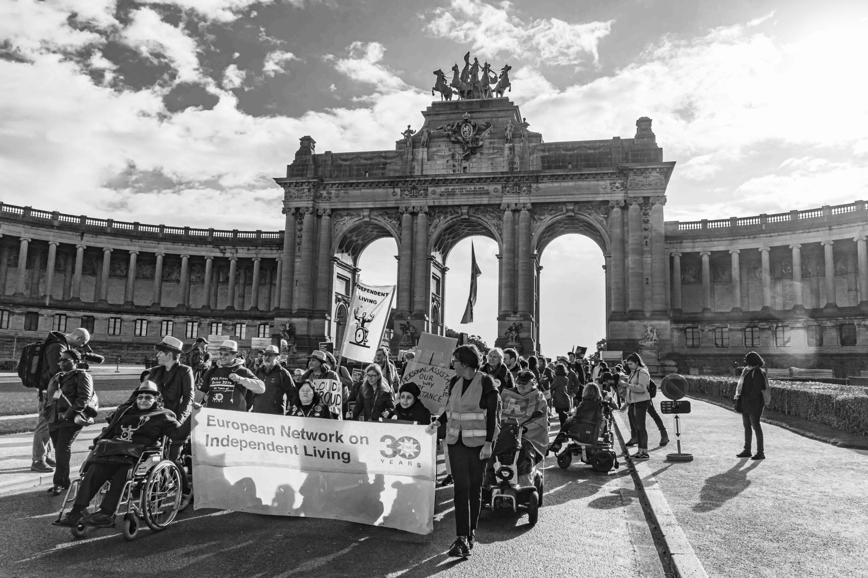
Introduction and context
The “Independent (Living) Media” Survey for Youth - Summary Report
The „Independent (Living) Media” project was implemented from January to December 2025 by the ENIL Youth Network. It was funded by the European Youth Foundation of the Council of Europe, through the annual workplan grant.
The project was created in response to young persons with disabilities still being underrepresented in the digital media, especially when it comes to positive narratives, and their voices often not being heard. The existing narratives around disability representation still carry stigma, shame, and lack of an authentic, rights-based approach. Sometimes young persons with disabilities are not well equipped to handle these challenges, lacking knowledge and skills in media literacy and ethics that would help them advocate for themselves. Yet at the same time, there are young persons with disabilities who are experienced influencers and content creators, and groups of young persons with disabilities who already use the power of the digital media to effect change.
With this in mind, Independent (Living) Media was imagined as a tool, community, and platform for young persons with and without disabilities to discuss existing narratives and work together to reshape them, while deepening their understanding of human rights, advocacy, democratic principles, active participation and the Independent Living philosophy.
The project's main output are the Guidelines on Media Representation of Persons with Disabilities, which were co-created by the participants of the international summer school titled “Crip, Cut, Rewrite!” and built on rights-based representation of disability in the media. Their main goal is to equip young media workers, organisations and advocates with a framework to combat harmful narratives and address stories about disability and persons with disabilities with dignity and authenticity.

Aim and Objectives of the project:
The main aim of the project is to raise awareness about the misrepresentation of the narratives of persons with disabilities in the media and together with young people with (and without) disabilities and young media specialists, prepare guidelines on how to portray stories of persons with disabilities in the media with empathy, dignity and using a human-rights based approach.
The objectives are:
- To analyse how representation, misrepresentation, existing narratives, stereotypes in the media influence dignity and equal access to rights of young persons with disabilities.
- To explore how the media can be used as a tool for portraying and creating a shared understanding of the disabled experience.
- To empower young persons with (and without) disabilities to become active changemakers on local and international levels.
- To exchange experiences and insights on media representation of persons with disabilities among young people coming from different countries and cultures.
- To prepare guidelines on how to portray stories of persons with disabilities in the media based on the human rights approach and informed by the UN Convention on the Rights of Persons with Disabilities.

Key activities:
Activity 1: A survey exploring young people’s attitudes on disability representation
Activity 2: Three online workshops on disability rights and the media titled „Bound to The Script”
Activity 3: An International Summer school on Disability Representation in the Media
Activity 4: Communication and dissemination

Target Group:
Primary: Young persons with and without disabilities from the Council of Europe member states, who have an interest or a career in the media, disability and/or human rights.
Secondary: Disabled people’s organisations (DPOs), NGOs, youth organisations, individuals and companies working in the field of media or minority and human rights.

Project team:
Nina Portolan, project coordinator, vice-chair of the ENIL Youth Network
Laura Alčiauskaitė, lead trainer/facilitator
Weronika Knowska, senior trainer
Emmy Sefentin, senior trainer

The Independent (Living) Media Survey for Youth
The survey corresponds to Activity 1 in the above overview. It was conducted online, from February 18th to March 18th, and it gathered 58 responses from 17 council of Europe member states, with additional insights sent from Egypt.
Its purpose was to provide insight into the experiences, views and attitudes of young people when it comes to representation, misrepresentation, narratives and stereotypes around disability that exist in the media.
The survey was aimed at two target groups:
1. Young disabled people 16-35
2. Young media professionals 16-35
In addition to completing the survey as a young person belonging to one or both target groups, responders had an opportunity to express their interest in attending online workshops on a variety of media-related topics, informing Activity 2, as well as in being interviewed to speak about their experiences in more depth, with the interviews being published on a project dedicated Instagram page @independent_living_media and the ENIL website.

Survey Findings (Summary)

Demographic information:
The two most common age groups of responders were 21-25 and 26-30, with a majority being female (37 respondents). Over half of those who took the survey identified as disabled, 12 identified as young media professionals, and 11 identified as belonging to both target groups.

Findings:

When asked „What Does Media Representation Mean to you?” respondents of the survey described representation as a tool for visibility, authentic storytelling, shifting perceptions, fostering inclusion, and empowering future generations. According to the survey, seeing disabled people represented can provide positive role models, and representation is tied to belonging, diversity, and being accepted as equal members of society. The media strongly influences both society’s attitudes and self-image of disabled people, so the respondents also expressed a strong desire for accurate, realistic portrayals, avoiding tokenism and stereotypes.
Based on open-ended responses, participants described media representation as:
- Visibility & being seen (16 mentions)
- Shaping perceptions (10 mentions)
- Authenticity and truth (7 mentions):
- Inclusion and equality (6 mentions):
- Empowerment and role models (4 mentions)

When asked what they thought about disability representation in the media now, the respondents who identified as disabled said it was „not good” (54,3%) or „ok, but could be better” (45,7%). Young media professionals (including those who were also disabled) responded similarly with an even higher percentage describing it as „not good” (66,7%).
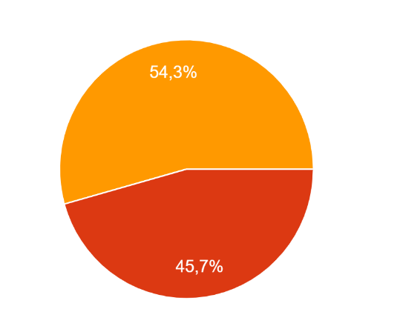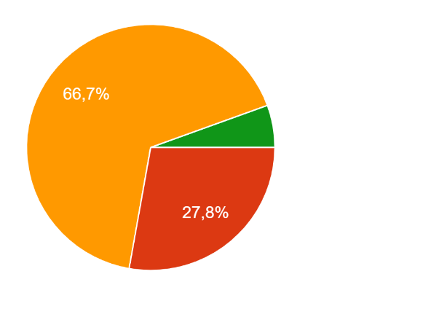
Figure 1: Pie charts displaying how young disabled people and young media professionals described representation of disability at the time of the survey.
Surprisingly, the majority of those who responded to the survey (35 respondents) had been featured in the media, although 29 described that they rarely saw disability represented in TV shows, film or other media formats. This might point to a conclusion that while young people who are active in the disability rights and other social movements have a somewhat higher chance of being in media spaces, representation of disability is still largely absent in mainstream media.
Furthermore, most respondents of the Independent (Living) Media survey for Youth described that when disabled people are shown in the media, they are predominantly portrayed either as inspiring and heroic or as a burden and a tragedy. The most commonly listed stereotypical traits of disabled people shown in the media included that they are dependent on others, always sad, brave or inspirational, strange or that they are often only shown in hospitals or situations when needing help.
When asked “Do you think the media often shows disabled people as fully developed characters, or just their disability?” 50% of respondents said that portrayal focuses only on the disability, and while about 45% said „both“, only one respondent felt that disabled people were truly portrayed as full, complex characters.
Over 80% of respondents in both target groups expressed that media representation had a significant influence on society’s views on disability.
Disabled respondents expressed said that stereotypes and misrepresentation in the media strongly impacted them, scoring the impact on their personal life at 4 or 5 on a 1-5 scale. They had strong negative feelings about existing narratives, citing frustration, alienation, and sadness among others. They were upset at the overuse of stereotypes, tokenism, and “inspiration porn”.
One respondent shared: „I feel that disabled people are always seen as some non-human creature that has a disability. The dehumanisation is so powerful that disability-related narratives are always reduced to the disability itself, as if this was the only experience we have... “
In an attempt at mapping good practices and examples of rights-based and authentic representation, both target groups were asked to describe what the media does well and offered space to share any examples they might have. The respondents acknowledged that there is more representation and space being given to disabled people in film and TV, but mentioned that these opportunities are still very rare.
Examples of positive portrayal included the TV series „Sex Education“, „Breaking Bad“, „Extraordinary Attorney Woo“ (South Korea) and select episodes in other shows, as well as films such as „Crip Camp“ and more recently the portrayal of Nessarose by Marissa Bode in „Wicked“. The respondents also included many influencers, activists and other individuals active on social media, highlighting the importance of this form of media for representation in today’s society.
While some positive examples in both target groups included non-disabled actors playing disabled characters, such as in the film „My left foot“, an overwhelming majority of disabled respondents see non-disabled actors playing disabled characters as inappropriate or offensive (28,3% each). Some respondents who felt it was acceptable still pointed out that this practice takes opportunities away from disabled creatives, whose opportunities are already limited.
Similarly, to the first target group, young media professionals felt that it was important to cast disabled actors as disabled characters, with a majority of 66,7%. The remaining responders thought it depends on the role, some explaining that they would hope the role of a disabled person would raise awareness and expand understanding of non-disabled performers.

Specific findings about young media professionals:
Young media professionals who responded to the Survey were mostly journalists or journalism students, filmmakers or content creators.
When asked how often they included disability and disabled people in their work, most said that they rarely do so, with “rarely” and “sometimes” as the most common answers with 33% each.
The most common challenges young media professionals face when portraying disability and disabled people were:
- Lack of knowledge about disability issues
- Fear and uncertainty about how to portray these stories
- Lack of resources
Several responders also highlighted that they experienced pressure to stereotype, that these stories were not getting enough attention, or that they struggled to find disabled subjects in their field/topic.
72% of young media professionals think there isn’t enough disability representation in the media they work with.
According to the responders, the most common reasons disabled people are underrepresented in the media include lack of knowledge and awareness, bias, gatekeeping, attitudes in the industry and inaccessible spaces.
The lack of knowledge and awareness is easily further explained as only 22% of media workers and students received any training on adequate representation. Among those who did receive training, most sought out these opportunities independently, or have lived experience of disability.

Conclusions and aims for the future:

The “Independent (Living) Media Survey for Youth” provided important insight into the views and opinions of young people on both sides of the lens: those creating media, and those consuming it, those who have the opportunity to tell stories, and those whose stories are being told. Their common sentiment: a need for change.

Young people in media spaces today showed awareness of the social issues reflected in the digital sphere, and a strong desire for more authentic portrayals, seeing disabled actors in disabled roles, and a media space that avoids stereotypes and nurtures authenticity.
They want to see disability representation in depictions of ordinary lives, such as disabled people in leadership positions or love stories, portrayed as full, nuanced people, empowered and not defined solely by disability.
In both target groups, young people emphasised the importance of having more stories that feature disability, more diversity, respect, more complexity in their stories and more disabled professionals taking space in the industry.
To begin the process of providing these opportunities and opening conversations, the project team prepared three online workshops (corresponding to Activity 2), facilitated by guest experts, on the topics most selected by responders of this survey:
- Stereotypes and Language around disability (22.04.2025)
- Inspirational narratives and their true impacts (29.04.2025)
- Authentic representation and storytelling (06.05.2025.)
An article about these workshops, written by one of the guest facilitators, is available here.

We hope that the “Independent (Living) Media” Project and the “Independent (Living) Media Survey for Youth” will be the beginning of a shift in how disability is portrayed, and perceived. The learnings thought the project have empowered and mobilised young changemakers across Council of Europe member States who remain loud and clear in one message: “More!”.

*This summary report was produced by Nina Portolan as part of the “Independent (Living) Media” project, implemented by the ENIL Youth Network and funded by the European Youth Foundation of the Council of Europe.
*The views and opinions expressed in this publication are the sole responsibility of the author and do not represent the official opinions of the Council of Europe.

Under the definition of media, we consider broadcast media (television, film, radio, podcast etc.), and all forms of digital media (social media, websites, marketing etc.).
Under the definition of media professionals, we include students training for roles in the media (such as journalists, presenters, filmmakers, reporters etc.) and those currently working in the media. This includes those in traditional broadcast roles listed above, and those creating content on digital platforms, like bloggers and social media influencers.

