Amendments to the Global Europe programme

Technical title of the regulation: Proposal for a Regulation of the European Parliament and the Council establishing Global Europe COM(2025) 551final

These amendments have been endorsed by the following organisations:

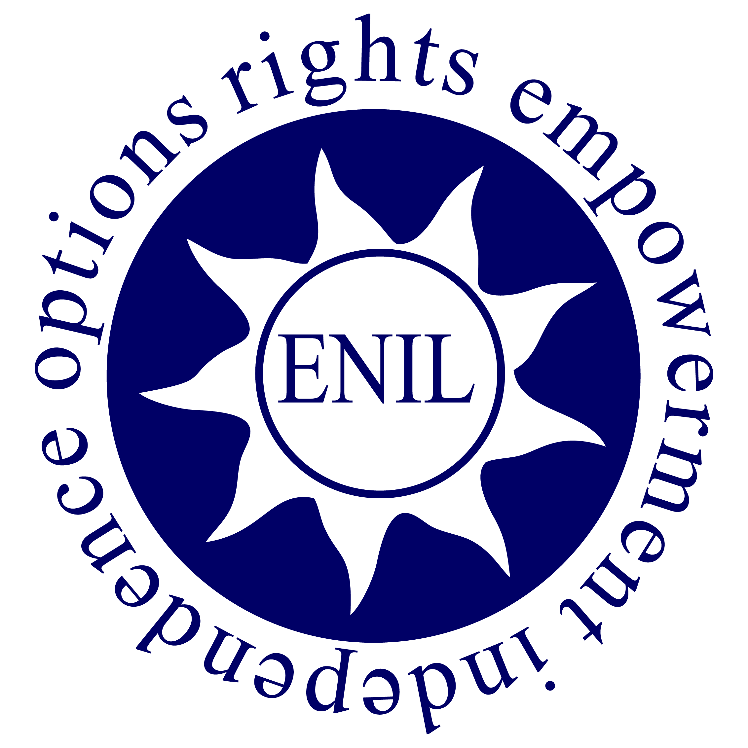 | The European Network on Independent Living (ENIL) is a disabled-led, cross-disability network of disabled people and their representative organisations. ENIL promotes the right to independent living, as set out in Article 19 of the UN Convention on the Rights of Persons with Disabilities (CRPD).
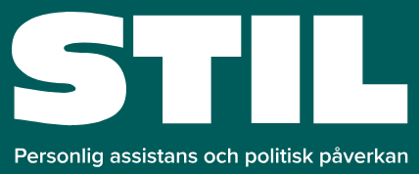 | STIL is, in Swedish, short for The Founders of Independent Living in Sweden. Our organization was founded in 1984, by and with people with disabilities. We were the first in Sweden to offer personal assistance. STIL’s goal is for everyone to be in control of their own life. Personal assistance is the criterion to guarantee everyone’s right to live their life the way they want.
 | ISL is the federal association of the Centers for Independent Living (ZsL®) in Germany. We are a cross-disability self-advocacy organization of persons with disabilities. This means that it is organized, led, and managed by people with disabilities themselves. ISL is active at the national political level.
 | Validity is a creative legal organisation dedicated to advancing the human rights of persons with intellectual disabilities and with psychosocial disabilities through strategic litigation, advocacy, research, and capacity-building, using tailored approaches to address entrenched human rights violations.
 | The European Federation of Hard of Hearing People (EFHOH) was established in 1993. EFHOH consists of organizations of/for hard of hearing and late-deafened people, parent organizations, and professional organizations at a European level.
 | Founded in September 2018, CLE Autistes is a non-profit association. It is led by and for people affected by autism and any learning difficulties, is non-partisan, and brings together more than 100 members.  We welcome everyone, with or without an official diagnosis, with learning difficulties, intellectual disabilities, non-speaking / non-verbal individuals, with various disabilities or without disabilities / neurodivergent. We categorically reject elitism.
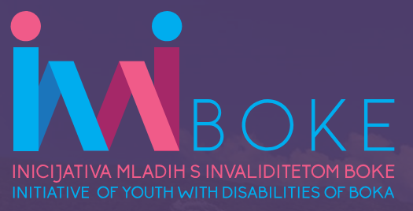 | The Initiative of Youth with Disabilities of Boka (IYDB) is a non-profit, non- governmental organization, founded on April 11. 2019. in Kotor, and registered in May of the same year. Children, young people and adults with all types of disablement, as well as other citizens interested in improving the position of these people in society, voluntarily associate in the IYDB.
 | The Association is constituted by a group of people with and without functional diversity, who imbued with the Philosophy of Independent Life, we intend to change the point of view that society, particularly Andalusian, has on people traditionally called disabled, especially those who depend on others for the development of their lives.
 | Our Mission To safely integrate families and children of Autism including others At-Risk, back into society through UNCONDITIONAL LOVE and SUPPORT one Step, one City, one ACRE at a time.
 | ASSOCIATION INDAR Inclusion Needs Diversity Action Respect for Social, labor and cultural inclusion
 | NPO “Me Alla Matia” was founded in 2018 by the blind lawyer Vaggelis Avgoulas and a group of disabled people claiming inclusion. It was implemented as an afterthought of the fully accessible news portal meallamatia.gr. “Me Alla Matia” means “with a different point of view” in Greek; that is how we aspire to make the world see diversity.
 | The NGO Alliance of Women with Disabilities was founded on June 25, 2021, in Batumi, Georgia. The Alliance primarily focuses on women with disabilities, though non-disabled women—such as parents, legal representatives, or other women-focused organizations—can join, provided they do not exceed 25% of total members. The organization operates at municipal, regional, and national levels.

Our organisations are recommending changes to Global Europe. We ask all parties involved to effectuate the following modifications:

1. Turn Global Europe into a programme that strongly supports the rights of persons with disabilities

A key objective of Global Europe is to promote our values which are rooted in our commitment to human rights.
The United Nations Convention on the Rights of Persons with Disabilities (UN CRPD) is one of the major international thematic human rights treaties. The European Union is a party to the UNCRPD which is part of the Unions’ legal order. The UN CRPD is the only international human rights treaty the EU is party to.
The ratification of the UN CRPD by the EU and all its member states shows that the rights of persons with disabilities are an intrinsic part of our values.

Articles 21 and 26 of the EU Charter of Fundamental Rights and article 19 of the Treaty of the Functioning of the European Union commit the EU to the pursuit of the equal treatment and social inclusion of persons with disabilities.

Given this inexorable commitment, we recommend giving the promotion of the rights of persons with disabilities a stronger role.

We recommend:

Amend article 4, 1b “Objectives of the instrument” and include the United Nations Convention on the Rights of Persons with Disabilities (UN CRPD)

Article 4, 1b states that Global Europe should contribute to the promotion of multilateralism and lists various international agreements the EU has concluded and whose implementation the programme should support. The UN CRPD is not listed. That is a missed opportunity which should be corrected.

Amend Article 9 (4) “General Principles” and list “equal treatment and social inclusion”, “Independent Living”, “personal assistance” and “deinstitutionalisation” as actions to be promoted

We welcome the reference to persons with disabilities. To ensure Global Europe generates investments that make a difference, we recommend adding precision by listing some of the objectives that should be pursued and actions to be financed.

Amend article 10 “Mainstreaming” and add “equal treatment and inclusion of persons with disabilities” to the list of topics

We welcome the mainstreaming of the fight against climate change, environmental protection, and gender equality. The equal treatment and social inclusion of persons with disabilities have a high standing in EU primary and secondary law and in EU policy making and thus should be directly mentioned among the topics to be mainstreamed.

Amend Article 23 “Implementation and forms of Union funding” and add a reference to the rights of persons with disabilities.

2. Ensure Global Europe takes into account the specific needs of women with disabilities

Persons with disabilities are a heavily marginalised group worldwide. Women with disabilities are more strongly affected by all the barriers persons with disabilities encounter. Women with disabilities are more frequently institutionalised and when in those settings at a high risk of forced sterilisation, depriving them of their reproductive rights. Women with disabilities who are mothers are doubly affected by the widespread unavailability of person-centred services to support them with their disabilities and of adequate childcare services, in particular when the child has a disability too.
In the fight for Gender Equality, the specific needs of women with disabilities are usually not taken into account.

We recommend:

Amend articles 9 - General Principles - 5 and 6 and add references to women with disabilities

3. Ensure organisations of persons with disabilities can participate in the programme

The empowerment of persons with disabilities to act as self-advocates is one of the key principles of the UN CRPD. Persons with disabilities shall no longer be seen as objects, a group decision are taken about but as subjects, a group that takes decisions about itself.
Organisations of persons with disabilities are controlled, run and staffed by persons with disabilities and play a key role in bringing this objective to live. Across the globe, such organisations are small, marginalised and struggle to be heard. A special awareness for their situation and needs is required, specific support needed.

We recommend:

Amend Article 2 - Definitions (8) and list the self-representation of persons with disabilities as entities which are distinct from civil society actors.

Amend Article 9 “General Principles” 3 and 9, Article 13 “General programming approach” 2 and Article 14 “Geographic programming principles” and add references to organisations of persons with disabilities.

We wish to present detailed amendments:

Global Europe as a global support instrument for the rights of persons with disabilities

Recital 48a (new)

Text proposed by the European Commission | Amendment
 | The instrument shall promote the rights of persons with disabilities by supporting the implementation of the United Nations Convention on the Rights of Persons with Disabilities Globally. Actions financed under the instruments shall be designed according to the authoritative documents issued by the UN Committee on the Rights of Persons with Disabilities and the European Commission Notice to Member States “Guidance on independent living and inclusion in the community of persons with disabilities in the context of EU funding”. In particular, recipients of funds shall implement actions supporting Independent Living and deinstitutionalisation, the access to person- centred services as well as the equal treatment and social inclusion of persons with disabilities.
Explanation:

As mentioned, the UN CRPD has a high standing in EU law because it is part of the Unions’ legal order. Council Decision of 26 November 2009 “concerning the conclusion, by the European Community, of the United Nations Convention on the Rights of Persons with Disabilities (2010/48/EC)” approved the UN CRPD on behalf of the EU.

Pursuant to Article 216(2) TFEU, agreements concluded by the Union are binding upon the institutions of the Union and on its Member States.

Letter (g) of the preamble to the UN CRPD emphasises “the importance of mainstreaming disability issues as an integral part of relevant strategies of sustainable development”.

UN CRPD article 19 on Independent Living grants persons with disabilities the right of choices equal to others, full inclusion and participation in the community and access to person-centred services. It is unique in that it relates to all other articles of the Convention.

Given this background, listing the UN CRPD is well justified.

Article 34 of the UN CRPD provides for the Committee on the Rights of Persons with Disabilities (CRPD Committee) which reviews the performance of state parties in implementing the Convention on a regular basis. To facilitate the interpretation of the Convention, the CRPD Committee issues General Comments and Guidelines. These documents are to be regarded as authoritative.

The 2025 European Commission Guidance on Independent Living was adopted to provide guidance on the usage of EU funding. It recommends investments in person-centred services, for example personal assistance.

Those documents guide the EU’s legal and policy activities on disability and should be used to guide the Union’s funding programmes.

In Europe and beyond there is a great scarcity of person-centred services.

Listing those priorities directly, will ensure increased investments.

The equal treatment and social inclusion of persons with disabilities have a high standing in EU law and policy making and should thus be mentioned directly.

According to article 21 of the EU Charter on Fundamental Rights, discrimination on the ground of disability is prohibited. According to article 26, the Union recognises and respects the right of persons with disabilities to benefit from measures designed to ensure their independence, social and occupational integration and participation in the life of the community.
The European Strategy on the Rights of Persons with Disabilities is the EUs’ multiannual policy framework.

Together, those documents demonstrate how important the rights of persons with disabilities are for the EU, justifying references.

Article 4 - Objectives of the Instrument - 1b

Text proposed by the European Commission | Amendment
(b) to contribute to the promotion of multilateralism and a rules-based international order, the achievement of the international commitments and objectives that the Union has agreed to, in particular the sustainable development goals, the 2030 Agenda, the Paris Agreement and the Kunming-Montreal Global Biodiversity Framework; | (b) to contribute to the promotion of multilateralism and a rules-based international order, the achievement of the international commitments and objectives that the Union has agreed to, in particular the sustainable development goals, the 2030 Agenda, the Paris Agreement, and the Kunming-Montreal Global Biodiversity Framework and the United Nations Convention on the Rights of Persons with Disabilities;

Article 9 - General Principles - 4

Text proposed by the European Commission | Amendment
4. Actions under this Instrument shall apply a human rights-based approach encompassing all human rights. That approach shall be guided by the principles of ‘leaving no one behind’, equality, non-discrimination on any grounds, including towards persons with disabilities. | 4. Actions under this Instrument shall apply a human rights-based approach encompassing all human rights. That approach shall be guided by the principles of ‘leaving no one behind’, equality, non-discrimination on any grounds, including towards persons with disabilities. Actions shall promote the equal treatment and social inclusion of persons with disabilities by providing investments in independent Living, including the provision of personal assistance and progress on deinstitutionalisation.

Article 10 - Mainstreaming

Text proposed by the European Commission | Amendments
Programmes and actions under the Instrument shall mainstream the fight against climate change, environmental protection and gender equality, in accordance with Regulation (EU, Euratom) [XXX] [Performance Regulation]. Those priorities shall be considered in the design and implementation of actions under the Instrument, with the aim to create co-benefits and meet multiple objectives in a coherent way. | Programmes and actions under the Instrument shall mainstream the fight against climate change, environmental protection, and gender equality and equal treatment and social inclusion of persons with disabilities, in accordance with Regulation (EU, Euratom) [XXX] [Performance Regulation]. Those priorities shall be considered in the design and implementation of actions under the Instrument, with the aim to create co-benefits and meet multiple objectives in a coherent way.

Article 23 - Implementation and forms of Union funding

Text proposed by the European Commission | Amendment
6. Budget support, including through sector reform performance contracts, shall be based on country ownership, mutual accountability and the commitment of partner countries, taking into account their record and progress with regard to universal values, democracy, human rights and the rule of law, and aims to strengthen partnerships between the Union and partner countries. It shall include reinforced policy dialogue, capacity building and improved governance, complementing partners’ efforts to collect more and to spend better in order to support sustainable, inclusive growth and decent job creation, including for young people poverty eradication, inequality reduction, and to build and consolidate democracies and peaceful societies. Budget support shall also contribute to gender equality. | 6. Budget support, including through sector reform performance contracts, shall be based on country ownership, mutual accountability and the commitment of partner countries, taking into account their record and progress with regard to universal values, democracy, human rights, including the rights of persons with disabilities and the rule of law, and aims to strengthen partnerships between the Union and partner countries. It shall include reinforced policy dialogue, capacity building and improved governance, complementing partners’ efforts to collect more and to spend better in order to support sustainable, inclusive growth and decent job creation, including for young people poverty eradication, inequality reduction, and to build and consolidate democracies and peaceful societies. Budget support shall also contribute to gender equality.

Taking into account the specific needs of women with disabilities

Recital 47

Text proposed by the European Commission | Amendment
(47) The implementation of the Instrument should be guided by the principles of gender equality, women and girls’ empowerment and of preventing and combating violence against women and domestic violence and should seek to protect and promote women’s rights in line with the Roadmap on Women’s Rights, Gender Equality Strategy, EU Gender Action Plans, relevant Council conclusions and international conventions, including the Istanbul Convention on violence against women. Strengthening gender equality and women’s empowerment in the Union’s external action and increasing efforts to reach the minimum standards of performance indicated by the EU Gender Action Plans should lead to a gender sensitive and transformative approach in all Union external action and international cooperation. Gender equality and women’s and girls’ empowerment should be mainstreamed under the Instrument and adequately reflected across all the actions. | (47) The implementation of the Instrument should be guided by the principles of gender equality, women and girls’ empowerment and of preventing and combating violence against women and domestic violence and should seek to protect and promote women’s rights in line with the Roadmap on Women’s Rights, Gender Equality Strategy, EU Gender Action Plans, relevant Council conclusions and international conventions, including the Istanbul Convention on violence against women. Strengthening gender equality and women’s empowerment in the Union’s external action and increasing efforts to reach the minimum standards of performance indicated by the EU Gender Action Plans should lead to a gender sensitive and transformative approach in all Union external action and international cooperation. Gender equality and women’s and girls’ empowerment should be mainstreamed under the Instrument and adequately reflected across all the actions. The instruments shall finance actions to combat violence and discrimination against disabled women, including gender and disability-based violence, confinement to institutions, forced sterilisation and contraception. It shall support the access to parenthood of persons with disabilities, including to sexual and reproductive healthcare services. It shall support the accessibility of childcare services and the inclusiveness of mainstream childcare services for children with disabilities.
Explanation:

Letter (q) of the preamble to the UN CRPD recognises “that women and girls with disabilities are often at greater risk, both within and outside the home, of violence, injury or abuse, neglect or negligent treatment, maltreatment or exploitation”.

Letter (s) emphasises “the need to incorporate a gender perspective in all efforts to promote the full enjoyment of human rights and fundamental freedoms by persons with disabilities”.
The figures presented are about the EU but there is no reason to believe that the situation outside the Union is better.

There is empirical evidence of the challenges women with disabilities face.

According to the European Parliament, within the EU disabled women and girls are 2 to 5 times more likely to experience violence than non-disabled women.
34% of women with a health problem or a disability have experienced physical or sexual violence by a partner during their lifetime, compared to 19% of women without disabilities.
61% have experienced sexual harassment since the age of 15, compared to 54% of women without disabilities.
According to the European Disability Forum (EDF), in 13 EU countries forced sterilisation of persons with disabilities is still legal, disproportionately affecting women and girls. Disabled women are also significantly more likely to experience sexual violence, harassment, domestic abuse and violence in institutional settings.

Article 9 - General Principles - 5 and 6

Text proposed by the European Commission | Amendment
5. The Instrument shall promote gender equality and girls’ and women’s empowerment and prevent and fight violence against women and domestic violence. It shall also give particular attention to the rights of the child and to the protection and empowerment of youth. | 5. The Instrument shall promote gender equality and girls’ and women’s empowerment with a particular focus on the equal treatment of women with disabilities and prevent and fight violence against women and domestic violence. It shall also give particular attention to the rights of the child and to the protection and empowerment of youth.
6. The Instrument shall be implemented in full accordance with the Union commitment to the promotion, protection and fulfilment of all human rights and to the full and effective implementation of the Beijing Declaration and the Platform for Action of the International Conference on Population and Development and the outcomes of their review conferences and remains committed to sexual and reproductive health and rights, in this context. The Instrument shall also support the Union commitment to the promotion, protection and fulfilment of the right of every individual to have full control over and decide freely and responsibly on matters related to their sexuality and sexual and reproductive health, free from discrimination, coercion and violence. It shall also support the need for universal access to quality and affordable comprehensive sexual and reproductive health information, education, including comprehensive sexuality education, and health-care services. | 6. The Instrument shall be implemented in full accordance with the Union commitment to the promotion, protection and fulfilment of all human rights and to the full and effective implementation of the Beijing Declaration and the Platform for Action of the International Conference on Population and Development and the outcomes of their review conferences and remains committed to sexual and reproductive health and rights, including of women with disabilities, in this context. The Instrument shall also support the Union commitment to the promotion, protection and fulfilment of the right of every individual to have full control over and decide freely and responsibly on matters related to their sexuality and sexual and reproductive health, free from discrimination, coercion and violence. It shall also support the need for universal access to quality and affordable comprehensive sexual and reproductive health information, education, including comprehensive sexuality education, and health-care services.

Ensuring the participation of organisations representing persons with disabilities

Article 2 - Definitions (8)

Text proposed by the European Commission | Amendment
(8) ‘civil society organisation’ means a wide range of actors with multiple roles and mandates, which may vary over time and across institutions and countries, and includes all independent non-State, not-for-profit and non-violent structures, through which people organise the pursuit of shared objectives and ideals, including political, cultural, religious, environmental, social or economic,, and which operate at local, national, regional or international levels, and which comprise urban and rural, formal and informal organisations; | (8) ‘civil society organisation’ means a wide range of actors with multiple roles and mandates, which may vary over time and across institutions and countries, and includes all independent non-State, not-for-profit and non-violent structures, through which people organise the pursuit of shared objectives and ideals, including political, cultural, religious, environmental, social, the self-representation of persons with disabilities or economic,, and which operate at local, national, regional or international levels, and which comprise urban and rural, formal and informal organisations;
Explanation:

Letter (o) of the preamble to the UN CRPD considers “that persons with disabilities should have the opportunity to be actively involved in decision-making processes about policies and programmes, including those directly concerning them”.

UN CRPD article 4 “General Obligations” states that state parties shall “closely consult with and actively involve persons with disabilities, including children with disabilities, through their representative organizations” in all legislative, policy and decision-making processes that concern persons with disabilities.

UN CRPD article 29 on participation in political and public life states that state parties have to actively promote an environment in which persons with disabilities can effectively and fully participate in the conduct of public affairs which entails:

“Forming and joining organizations of persons with disabilities to represent persons with disabilities at international, national, regional and local levels.”

Given the high status the UN CRPD grants the self-representation of persons with disabilities a direct reference is duly justified.

Article 9 - General Principles - 3 and 9

Text proposed by the European Commission | Amendments
3. The Union shall seek to promote, develop and consolidate the principles of democracy, good governance, the rule of law and respect for human rights and fundamental freedoms on which it is founded, notably through dialogue and cooperation with partner countries and regions and with civil society, including through action in multilateral fora. | 3. The Union shall seek to promote, develop and consolidate the principles of democracy, good governance, the rule of law and respect for human rights and fundamental freedoms on which it is founded, notably through dialogue and cooperation with partner countries and regions, and with civil society and organisations of persons with disabilities, including through action in multilateral fora.
9. In accordance with the principle of inclusive partnership, where appropriate, the Commission shall ensure that relevant stakeholders of partner countries, including civil society organisations and local authorities, are duly consulted and have timely access to relevant information allowing them to play a meaningful role during the design, implementation and associated monitoring processes of programmes and actions under the Instrument. | 9. In accordance with the principle of inclusive partnership, where appropriate, the Commission shall ensure that relevant stakeholders of partner countries, including civil society organisations, organisations of persons with disabilities and local authorities, are duly consulted and have timely access to relevant information allowing them to play a meaningful role during the design, implementation and associated monitoring processes of programmes and actions under the Instrument.

Article 13 - General programming approach - 2

Text proposed by the European Commission | Amendments
2. On the basis of Article 8, programming documents shall provide a coherent framework for cooperation between the Union, partner countries or regions and other partners, consistent with the overall purpose and scope, objectives and principles set out in this Regulation.  The Commission shall consult other donors and actors, including local authorities, representatives of civil society and the private sector, where relevant.  The Commission shall inform the European Parliament and the Council about the outcome of the consultations envisaged under the second subparagraph. | 2. On the basis of Article 8, programming documents shall provide a coherent framework for cooperation between the Union, partner countries or regions and other partners, consistent with the overall purpose and scope, objectives and principles set out in this Regulation.  The Commission shall consult other donors and actors, including local authorities, representatives of civil society, including organisations of persons with disabilities and the private sector, where relevant.  The Commission shall inform the European Parliament and the Council about the outcome of the consultations envisaged under the second subparagraph.

Article 14 - Geographic programming principles

Text Proposed by the European Commission | Amendment
1. Programming under Article 3(2), point (a), shall be based on the following principles:  (a) actions shall be based, to the extent possible, on a dialogue between the Union, Member States and the partner countries concerned, including national, regional and local authorities, and involving civil society; | 1. Programming under Article 3(2), point (a), shall be based on the following principles:  (a) actions shall be based, to the extent possible, on a dialogue between the Union, Member States and the partner countries concerned, including national, regional and local authorities, and involving civil society, including organisations of persons with disabilities;

About the European Network on Independent Living
The European Network on Independent Living (ENIL) is a disabled-led, cross-disability network of disabled people and their representative organisations. ENIL promotes the right to independent living, as set out in Article 19 of the UN Convention on the Rights of Persons with Disabilities (CRPD), its General Comments and the Guidelines on deinstitutionalisation, including in emergencies. ENIL’s work is guided by the CRPD and the Independent Living principles, enshrined in the Independent Living Pillars. ENIL is active at the European level, and internationally, through cooperation with Centres for Independent Living from around the globe. ENIL’s actions and activities are based on the social and the human rights models of disability, and on the principles of inclusive equality, self-determination, solidarity and intersectionality.
ENIL has participatory status with the Council of Europe (i.e. is a member of the Conference of INGOs) and consultative status with ECOSOC.
Contact us
European Network on Independent Living (ENIL)
6thFloor – Mundo J
Rue de l’Industrie 10
1000 Brussels
Belgium
E-mail: secretariat@enil.eu
Website: www.enil.eu

Written by: Florian Sanden
© European Network on Independent Living, 2025



Co-funded by the European Union. Views and opinions expressed are however those of the author(s) only and do not necessarily reflect those of the European Union or the European Commission. Neither the European Union nor the granting authority can be held responsible for them.

https://www.ohchr.org/en/treaty-bodies/crpd
https://eur-lex.europa.eu/eli/C/2024/7188/oj/eng
https://www.europarl.europa.eu/RegData/etudes/BRIE/2025/775872/EPRS_BRI(2025)775872_EN.pdf
https://www.edf-feph.org/content/uploads/2022/09/EDF_FS_0909-accessible.pdf

