Joint call to ensure disability rights in the trilogue negotiation of the Regulation on Protection of Adults
8 April 2026
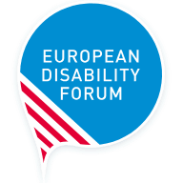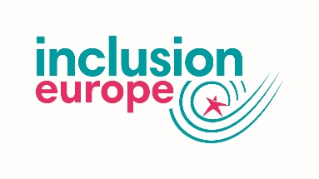



A group of equality organisations calls on the EU Institutions to ensure the EU’s Regulation on Protection of Adults protects the fundamental rights of persons with disabilities and older persons. The call is shared by the European Disability Forum, the European Network on Independent Living, Inclusion Europe, Mental Health Europe, European Council of Autistic People, Validity Foundation and AGE Platform Europe .
Our organisations recognise the importance of conflict of laws legislation as a means to provide legal certainty, avoid gaps and promote the uniform application of international law, including in the EU. However, we have expressed significant concerns that the text of the Regulation proposed by the European Commission in 2023 does not align with international human rights law.
The proposed text of the Regulation could result in further stripping away older people and persons with disabilities of their personal freedoms and rights of by automatically recognising judicial measures depriving them of their legal capacity, everywhere they go in the EU. It may also force living arrangements by coercing people into specific housing or institutional care against their will, even being transferred to another Member State to that end.
We welcome the efforts of the European Parliament and the Council of the EU to better align the text with the UN Convention on the Rights of Persons with Disabilities (CRPD), in their positions adopted in 2025 and 2026 respectively.
The draft Regulation is now under interinstitutional negotiations (trilogues) to agree the final text. We call on the EU institutions and all EU Member States to promote and protect the rights of all, in line with the Convention, recalling their commitments made in the Council Conclusions on the Protection of Vulnerable Adults across the European Union adopted in 2021.
We call on the negotiators to:
- Ensure the protection of people’s rights by recognising and focusing on supported decision-making regimes and mechanisms
- Guarantee that cross-border placements measures are only possible when they are based on the choice, autonomy and support of the persons and that they do not apply to placement of persons with disabilities in institutions
- Ensuring the privacy of citizens covered by the Regulation to ensure that data related to support in decision-making or power of representation are also shared after consent of the person
We proposed text to revise the proposal based on the UN Convention on the Rights of Persons with disabilities and the Charter of Fundamental Rights of the European Union.

Background
In May 2023, the European Commission published a proposal for a Regulation and Council Decision regulating the “cross-border ‘protection” of adults. This draft law is based on the 2000 Hague Convention on the international protection of adults, an international non-UN legal text regulating the rules applicable to the ‘protection’ of adults in cross-border situations.
The proposal concerns persons – mostly persons with disabilities and older adults – who are considered to “not be in a position to protect their own interest” and are in what is called a cross-border situation. These can be people that have money or properties (such as houses) in another country, who are seeking medical care abroad, or who relocate in another EU Member State.
More information.

