Promoting the Right to Independent Living for All Disabled People in Europe 2026

Project number 101266097 – PRIDE 2026
European Network on Independent Living - ENIL



Study Visit: Deinstitutionalisation and Personal Assistance – Ljubljana, Slovenia

1-2 July 2026

Written by: Dr. Veronika Kovács, Co-Production Officer

Table of Contents
Introduction 3
Day 1 - 1 July 5
09:00–12:00. Introduction to YHD and personal assistance 5
12:00–14:00 Deinstitutionalisation in Slovenia – introduction of Slovenia DI Centre 6
15:00–16:00 ENIL Presentation: Affordable and Accessible Housing & IL Quiz 8
Day 2 - 2 July 10
Conclusion 12
Annex 1 – Presentation: YHD: Personal Assistance in Slovenia 13
Annex 2 - Presentation: ENIL: Affordable and Accessible Housing 23

Study Visit: Deinstitutionalisation and Personal Assistance
1-2 July 2026, Ljubljana

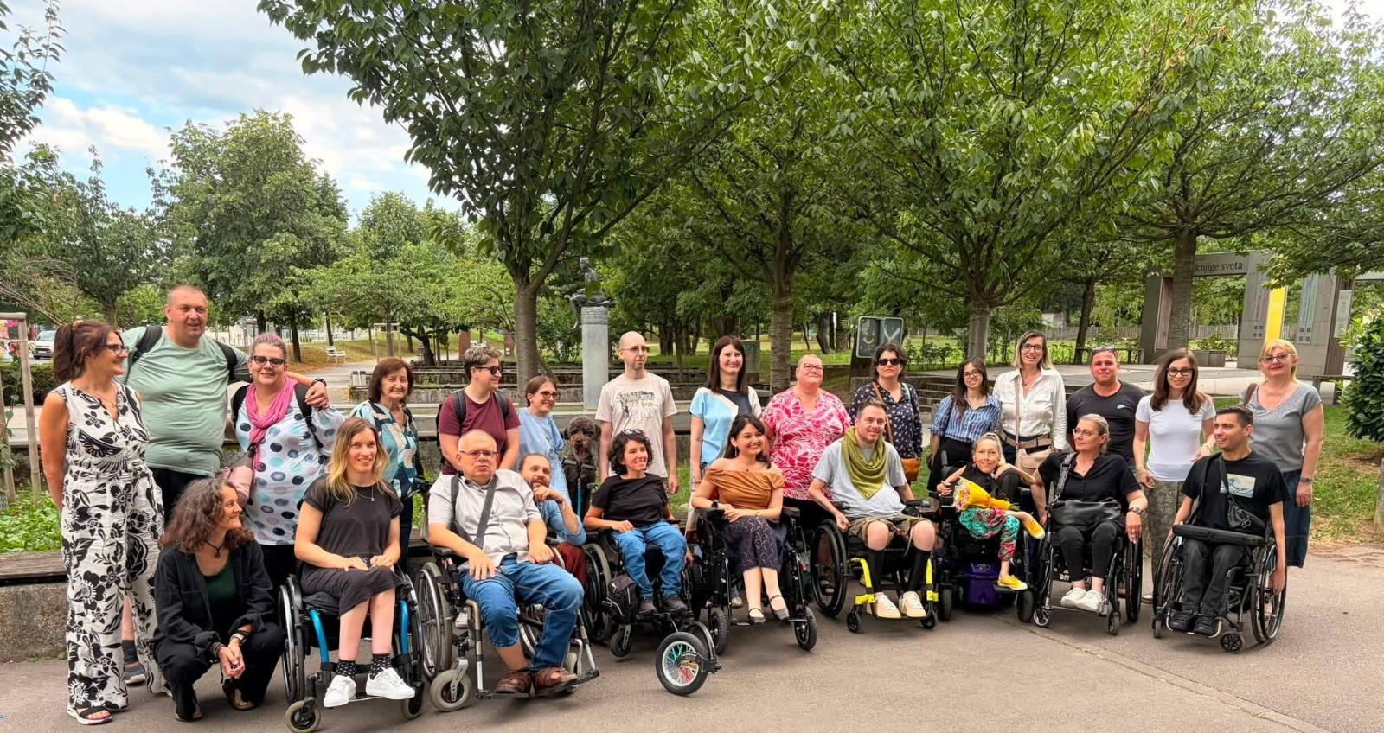
On 1–2 July 2026, ENIL organised a study visit to Ljubljana, Slovenia, to learn about personal assistance, deinstitutionalisation and Independent Living. Fourteen participants from across Europe took part in the visit, which was hosted by YHD – Association for Theory and Culture of Handicap.
The programme combined presentations, discussions and visits to housing settings and the homes of personal assistance users. Participants learned about Slovenia's experience with personal assistance and deinstitutionalisation and had the opportunity to see how Independent Living works in practice.
The study visit showed that personal assistance is an essential part of Independent Living, but it must be supported by accessible housing, community-based services and the gradual closure of institutions. Participants also exchanged experiences from their own countries and discussed common challenges and possible solutions.
The visit strengthened cooperation between disability organisations across Europe and provided participants with practical ideas and knowledge that they can apply in their own advocacy and work.

Introduction

The European Network on Independent Living (ENIL) is a Europe-wide disabled people's organisation working to promote the right to Independent Living and the full implementation of Article 19 of the UN Convention on the Rights of Persons with Disabilities (UN CRPD). Alongside its policy and advocacy work at the European level, ENIL regularly brings together its members and partners to exchange knowledge, share experiences, and strengthen the Independent Living movement across Europe.
With this objective, ENIL organised a Study Visit to Ljubljana, Slovenia, on 1–2 July 2026, bringing together 14 participants from across Europe. The visit aimed to provide an opportunity for peer learning and the exchange of good practices on personal assistance, deinstitutionalisation and community-based support. Participants were able to explore both the legal framework and the everyday realities of Independent Living in Slovenia.
The study visit was hosted by YHD – Association for Theory and Culture of Handicap, one of Slovenia's leading Disabled People's Organisations and a pioneer of the Independent Living movement in the country. For more than three decades, YHD has played a key role in advocating for the rights of disabled people, promoting personal assistance, and supporting the transition from institutional care towards community-based living. Through its long-standing experience in both advocacy and service provision, YHD offered participants valuable insight into the development of Slovenia's Independent Living movement.
Over the course of two days, participants took part in presentations, discussions and site visits, including visits to transitional housing and the homes of personal assistance users. These activities provided a unique opportunity to learn directly from disabled people and practitioners, exchange experiences from different national contexts, and reflect on how successful approaches can be adapted and promoted across Europe.
The study visit was coordinated on behalf of ENIL by Veronika Kovács and Christos Meletis, who accompanied the participants throughout the programme and facilitated the different sessions.
Participants arrived in Ljubljana on 30 June 2026, travelling from across Europe to take part in the two-day programme. To ensure the accessibility of the study visit, YHD generously organised accessible airport transfers and local transportation throughout the programme. Several participants also travelled with their personal assistants, enabling them to participate fully in all activities and discussions.
The official programme commenced on 1 July, beginning with a welcome from YHD and an introduction.

Day 1 - 1 July

09:00–12:00. Introduction to YHD and personal assistance
The first day of the study visit began with a welcome from both ENIL and YHD, followed by an introduction of the participants. The group brought together 14 participants from across Europe, representing Disabled People's Organisations, civil society organisations and advocacy groups from countries including Georgia, Armenia, France, Albania, Italy, Germany, Bosnia and Herzegovina, Montenegro, Hungary and Finland. Participants shared the situation of Independent Living in their respective countries, highlighting both achievements and the many challenges that remain. While some countries have established personal assistance systems, others continue to rely on institutional models of support.
The morning session was led by Klaudija Poropat, one of YHD's founding members, together with Elena Pečarič, President and Director of YHD and one of the pioneers of the Independent Living movement in Slovenia. Throughout the visit, they were supported by Sonja Korelc-Kotur and Natalija Jeseničnik, whose coordination, expertise and hospitality greatly contributed to the success of the programme. The YHD team introduced participants not only to the Slovenian personal assistance system but also to the history of the Independent Living movement in Slovenia.
Klaudija explained how personal assistance had developed in practice, the challenges encountered along the way, and the lessons learned over more than three decades of advocacy. The discussion also prepared participants for the following day's visits to the homes of personal assistance users.
The presentation traced the origins of YHD back to the early 1990s, when disabled activists came together to challenge institutionalisation and advocate for the right to live independently. Long before personal assistance became a legal entitlement, YHD developed its own personal assistance programme in response to the everyday needs of people who wanted to study, work and participate fully in society. At the time, the organisation relied on project-based funding and had to secure financial resources year after year to ensure the continuity of the service. Despite these challenges, YHD became one of Slovenia's leading promoters of user-led personal assistance and played a key role in advocating for the adoption of Slovenia's Personal Assistance Act.
The Act was adopted in 2017 and entered into force in 2019, marking a significant milestone for the Independent Living movement in Slovenia. However, YHD also reflected critically on the system's development. Public funding allowed personal assistance to expand rapidly. However, many new providers entered the sector without a strong understanding of the Independent Living philosophy. YHD expressed concern that the focus has increasingly shifted towards service provision rather than ensuring that the user remains in control of the support they receive.
Throughout the discussion, Klaudija often stressed that personal assistance is fundamentally different from caregiving. The defining principle is that the user directs the service, deciding what support is needed, when it is provided, how it is delivered and by whom. Personal assistants support the user in carrying out their decisions, and they do not make decisions on the user's behalf.
YHD has a strong approach to empowering users. From the very beginning, the organisation expected users to take an active role in managing their personal assistance, including recruiting and training their assistants. YHD has long invested in annual training sessions for both personal assistance users and personal assistants. They recognized that a successful personal assistance system depends not only on legislation, but also on knowledge, confidence, trust and mutual understanding. The organisation has always sought to equip users with the skills and confidence to advocate for themselves and exercise genuine choice and control over their support.
The discussion also touched upon several practical aspects of the Slovenian system. Participants learned that personal assistants can currently work a maximum of 56 hours per week, typically amounting to around 12–13 hours per day. The current hourly rate for personal assistance is approximately €20 per hour. YHD shared its concerns regarding proposed legislative amendments. They emphasized that some of the planned changes appear to prioritise the regulation of personal assistants and service providers rather than protecting the rights and autonomy of users.
Slovenia's personal assistance system is regarded as one of the most advanced in the region, attracting people from neighbouring countries who relocate in order to access support that is unavailable in their home countries.

12:00–14:00 Deinstitutionalisation in Slovenia – introduction of Slovenia DI Centre
The second session of the morning focused on deinstitutionalisation in Slovenia and was delivered by Dr Andreja Rafaelič and Dr Andraž Kapus from the Deinstitutionalisation Centre (DI Centre) at the Social Protection Institute of the Republic of Slovenia (IRSSV). Drawing on their expertise, experience in research, policy development and the practical implementation of deinstitutionalisation. They provided participants with a comprehensive overview of Slovenia's ongoing transition from institutional care towards community-based support.
The presentation began with an overview of the history of deinstitutionalisation in Slovenia and the role of the DI Centre in supporting this process. Dr Andraž Kapus introduced the Centre's work, explaining that it provides expert guidance to institutions undergoing transformation, supports multidisciplinary teams, develops individual transition plans and works closely with local authorities, service providers and people with lived experience. He emphasised that deinstitutionalisation should not be understood simply as relocating people into smaller settings, but rather as a systemic transformation that places the individual, their rights and their choices at the centre of support.
Building on this introduction, Dr Andreja Rafaelič reflected on Slovenia's experience over the past decades- She highlighted that deinstitutionalisation is fundamentally a human rights process rather than a housing or social care project. She repeatedly stressed that the goal is not merely to move people out of institutions, but to enable them to live meaningful lives in the community with the support they choose.
One of the most important messages of the sessions was that personal assistance alone does not achieve deinstitutionalisation. Andreja explained that while Slovenia has made significant progress in expanding personal assistance and other community-based services, these developments must go hand in hand with the gradual closure of institutions. Otherwise, the system will operate on two parallel tracks, with new community services developing while institutions continue to function unchanged. The development of high-quality community-based services and the closure of institutions must take place simultaneously, to achieve genuine deinstitutionalisation.
They also challenged the common assumption that replacing large institutions with smaller group homes is an adequate solution. Andreja emphasised that reducing the size of residential settings does not automatically change the culture of support. Without genuine choice, autonomy and control, smaller group homes can continue to reproduce institutional culture. Successful deinstitutionalisation therefore requires not only structural reform, but also a fundamental change in mentality, moving away from care-based approaches towards recognising disabled people as equal members of society with the right to make decisions about their own lives.
Participants were also introduced to ongoing policy developments in Slovenia. The DI Centre explained that new legislative reforms are currently being prepared to strengthen community-based services and further support the deinstitutionalisation process. One of the proposed measures aims to gradually reduce institutional capacity by ensuring that when a person successfully leaves an institution, their place is no longer filled by another person. Instead, institutional capacity would gradually decrease over time while community-based alternatives continue to expand.
During the session, the participants had the chance to raise their questions. Responding to a participant's question regarding individuals considered to be dangerous to themselves or others, Andreja explained that such cases represent only a very small proportion of institutional residents. As an example, she noted that in one particular institution, only around five out of approximately 600 residents would fall into this category. She said that exceptional cases should not be used to justify maintaining institutional systems for thousands of other people who could successfully live in the community with appropriate support.
As with the previous session, participants actively contributed to the discussion by sharing experiences from their own countries and raising important questions about housing, support, legal reforms and the practical implementation of deinstitutionalisation. The exchange highlighted that, despite different national contexts, many countries continue to face similar challenges in shifting from institutional models towards rights-based support.
Following the morning sessions, participants enjoyed lunch together at the YHD office. The lunch break also gave an opportunity to continue conversations from the morning, network and exchange experiences in a more informal setting.

15:00–16:00 ENIL Presentation: Affordable and Accessible Housing & IL Quiz
The afternoon programme continued with a presentation delivered by Veronika Kovács on behalf of ENIL, focusing on the European Commission's Affordable Housing Plan and its implications for disabled people and the Independent Living movement.
The presentation began by examining the current housing challenges faced by disabled people across Europe. Participants discussed the shortage of accessible housing, discrimination in the housing market, rising housing costs, the lack of social housing and community-based support services, and the link between inaccessible housing and institutionalisation. It was highlighted that more than 1.5 million disabled people continue to live in institutions, while many others remain at risk of housing exclusion because accessible housing is simply unavailable.
The presentation introduced ENIL's position on the European Commission's Affordable Housing Plan. While welcoming the Commission's recognition of the housing crisis, ENIL believes that accessibility must become a central component of all future housing policies. Emphasising that affordable housing alone is not enough, housing must also be accessible, support Independent Living and enable disabled people to participate fully in their communities. The presentation further emphasized that housing should be recognised as a fundamental human right, as reflected in international human rights instruments and the UN Convention on the Rights of Persons with Disabilities, particularly Articles 9, 19 and 28.
Veronika highlighted the strong connection between housing and deinstitutionalisation. ENIL calls for a "Housing and Support First" approach, highlighting that accessible housing must be accompanied by community-based support services. The presentation also outlined ENIL's recommendations on social housing, universal design, emergency preparedness, homelessness, accessible shelters, available disability disaggregated data and the importance of ensuring that EU funding supports accessible and inclusive housing rather than institutional or segregated settings.
The presentation was an introduction to the following day's programme, during which participants would visit accessible housing units and meet personal assistance users.
To conclude the first day, Christos Meletis facilitated an interactive quiz on the principles of Independent Living. The quiz revisited many of the topics discussed throughout the day, including personal assistance, deinstitutionalisation, the UNCRPD and ENIL's advocacy work. Participants tested their knowledge of the topics discussed throughout the day through the quiz. The three highest-scoring participants received small prizes, bringing the first day of the study visit to a close.

Day 2 - 2 July

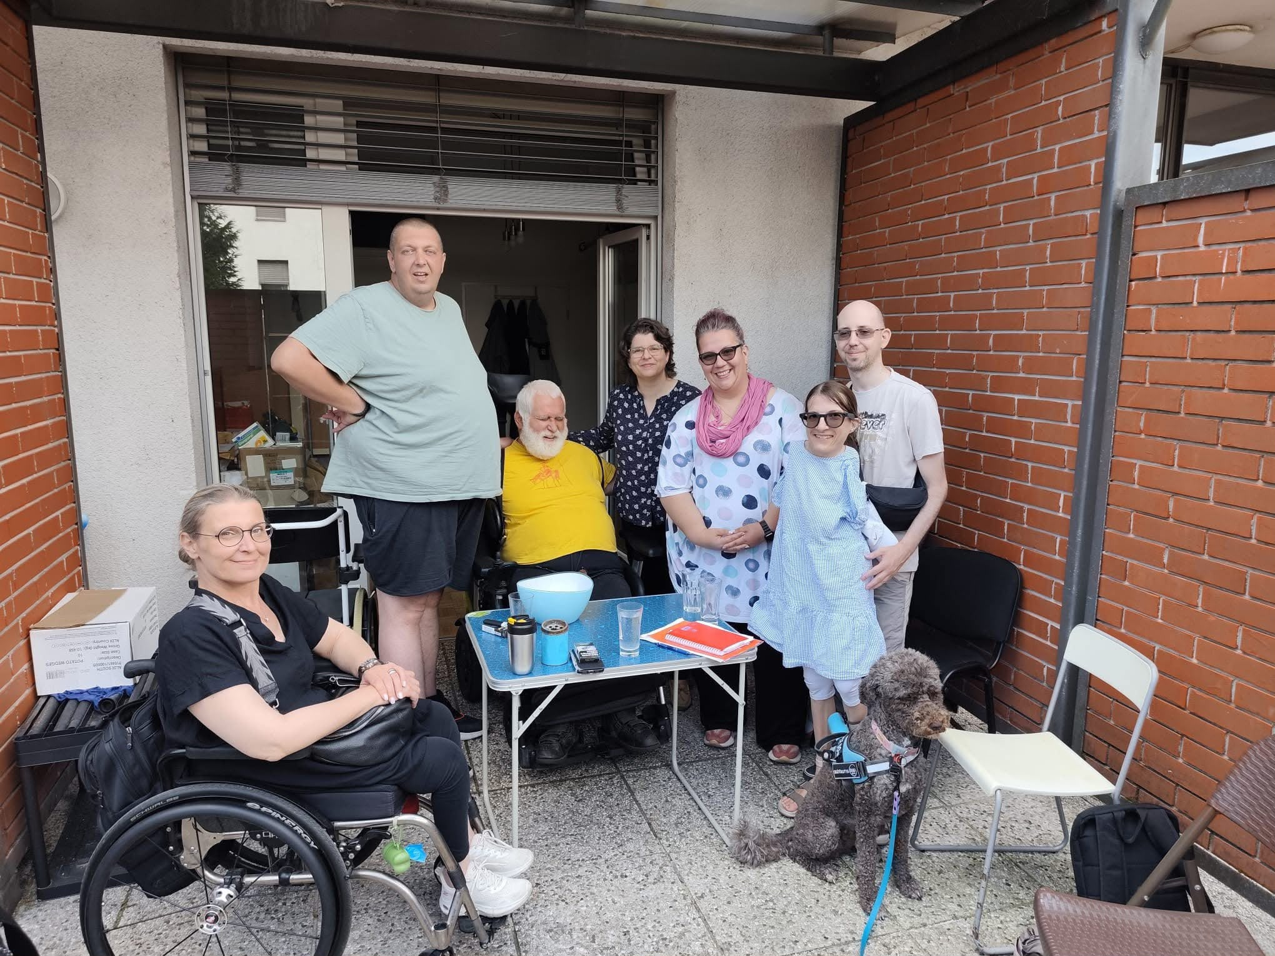
Following a full day of presentations and discussions, the second day of the study visit gave participants the opportunity to experience Independent Living in practice. Participants visited different housing settings across Ljubljana, allowing them to see how the principles discussed are translated into everyday life.
To ensure each participant has the chance to raise their questions and to focus on the users without being rushed, YHD offered four different transitional housing units and the homes of personal assistance users. The ENIL team joined the visit to Elena Pečarič's home, where participants had the opportunity to learn directly from one of the founder of YHD and a pioneer of the Independent Living movement in Slovenia.
Visiting Elena's home was undoubtedly one of the highlights of the study visit. After learning so much about YHD's history and Slovenia's personal assistance system, they had the opportunity to see how Independent Living works in practice. Elena Pečarič spoke openly about her daily life, her experience of using personal assistance, and the importance of having choice and control over the support she receives. Participants asked numerous questions about everyday life, relationships with personal assistants, accessibility, and other challenges she might face.
During the discussion, Christos asked Elena what Independent Living meant to her. She replied: "It means everything to me. The way I choose to live and the way I want to live." When asked what her life would look like without personal assistance, her answer was: "I would probably not be alive." These simple yet deeply personal reflections captured the significance of personal assistance more effectively than anything else could. They served as a powerful reminder that, for many disabled people, personal assistance is not merely a service, it is the foundation that makes Independent Living, ultimately, life itself possible.
Following the field visits, all groups returned to the YHD office for lunch, where participants shared their experiences. These were very emotional and honest discussions between the users and participants. Later, we received numerous feedback of how inspiring and educational these visits were. Most of the participants noted this as the highlight of the trip.
The study visit concluded with an interactive evaluation session facilitated by Veronika and Christos. Working in small groups, participants reflected on what had inspired them most, what they would take back to their own organisations, and how accessible and inclusive they found the programme. The feedback was overwhelmingly positive. Several participants also expressed that they would have appreciated more time for discussion and exchange. They expressed that they feel inspired, motivated to fight for change in their own country. YHD served as a great example of how much a strong community and commitment can achieve, and fighting for disability rights remains as important today as ever.
The programme concluded with final reflections, a group photograph and the presentation of bouquets of flowers to Elena Pečarič and Klaudija Poropat in recognition of their longstanding commitment to the Independent Living movement in Slovenia, and as a thank you for their warm welcome and hospitality towards the participants. Later that evening, participants gathered at Ljubljana Castle to visit an exhibition and enjoy a final opportunity to connect in an informal setting before returning home.

Conclusion
ENIL would like to express its sincere gratitude to YHD - Association for Theory and Culture of Handicap, in particular Elena Pečarič, Klaudija Poropat, Sonja Korelc-Kotur, Natalija Jeseničnik and Miranda Škaper, for their warm hospitality, kindness, professionalism and generosity in sharing their knowledge and experience throughout the study visit. Their commitment to advancing the rights of disabled people and promoting Independent Living made this study visit a valuable learning experience for all participants.
ENIL also extends its sincere thanks to all participants for their active engagement, thoughtful contributions and willingness to share experiences from their own national contexts, which greatly enriched the discussions and contributed to the success of the study visit.

Annex 1 – Presentation: YHD: Personal Assistance in Slovenia
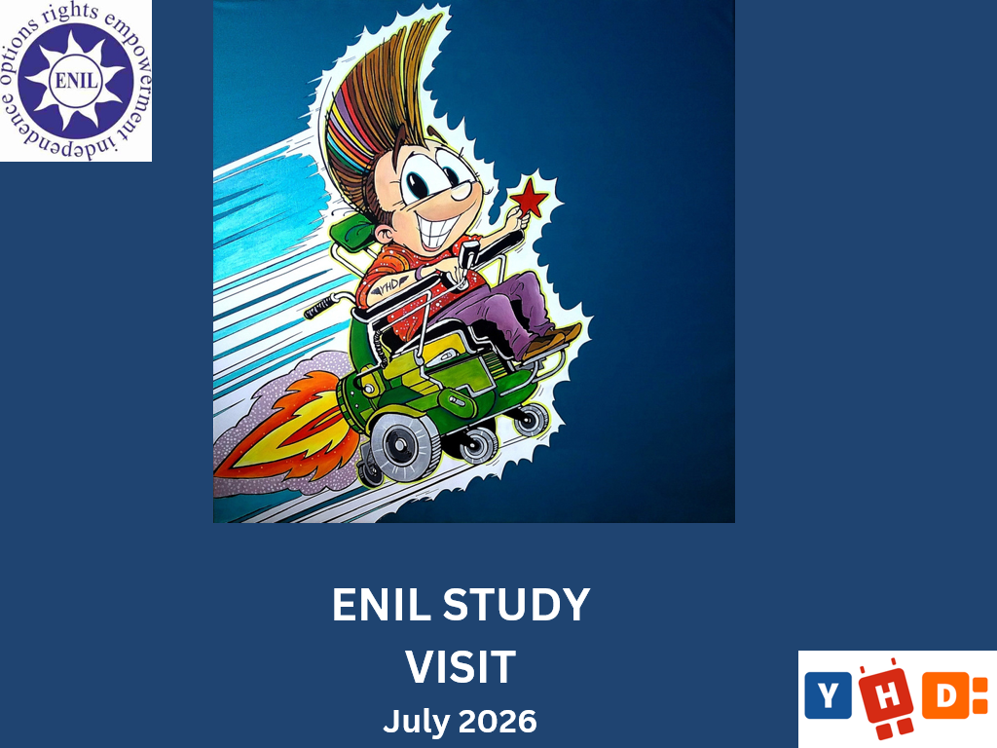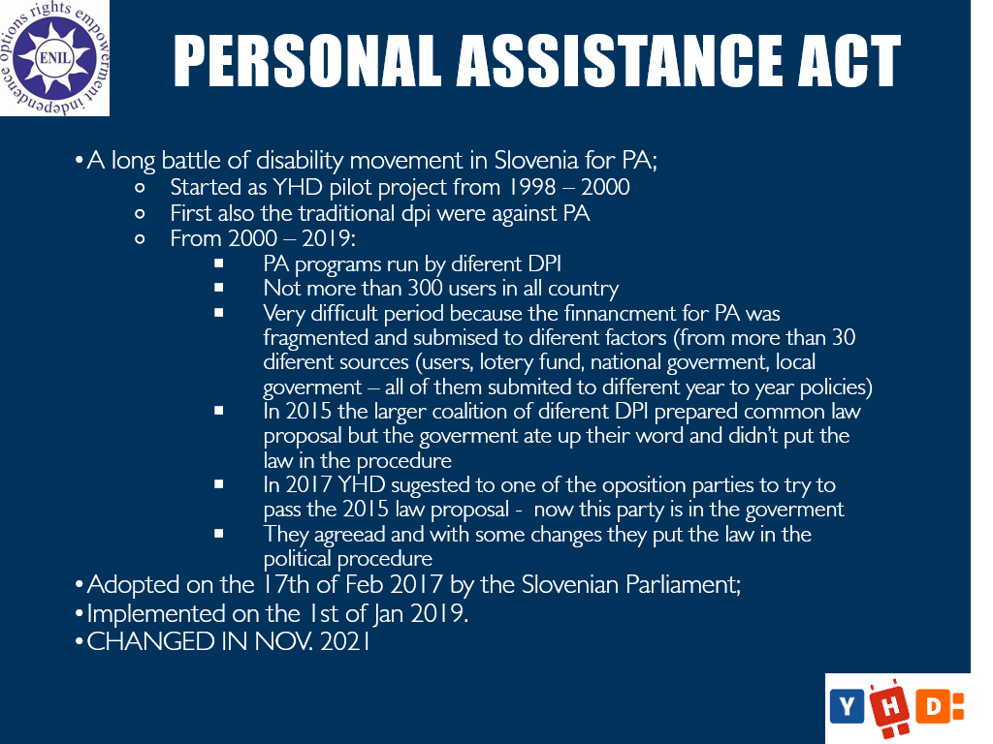
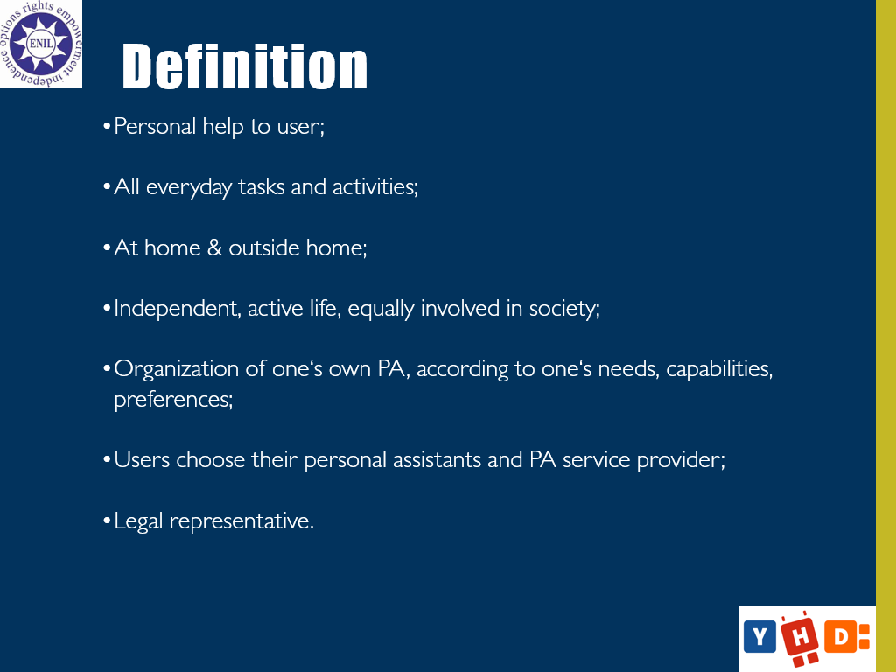
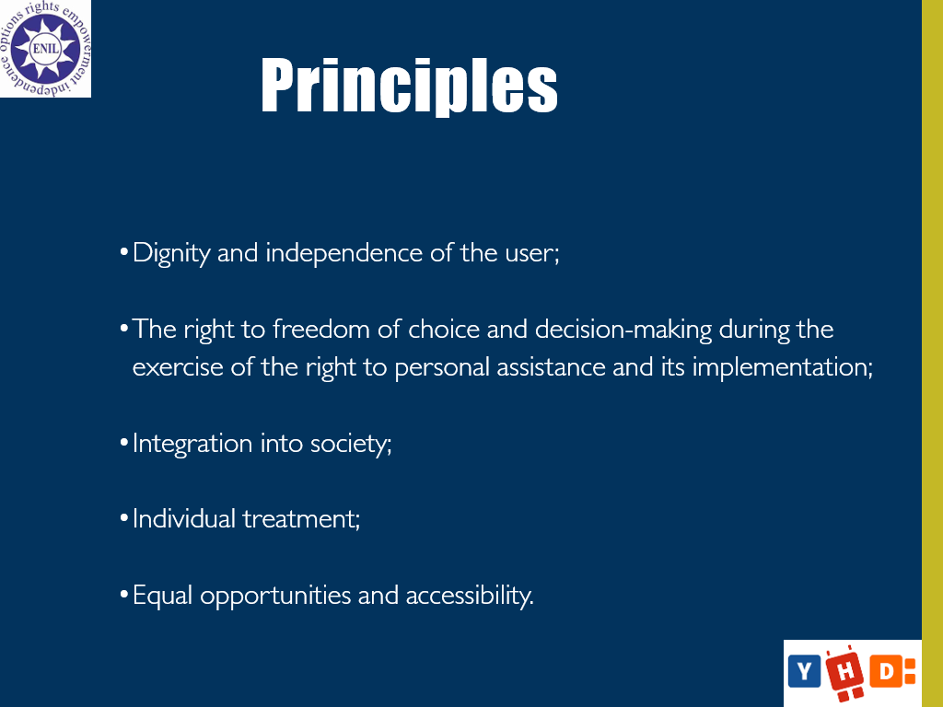
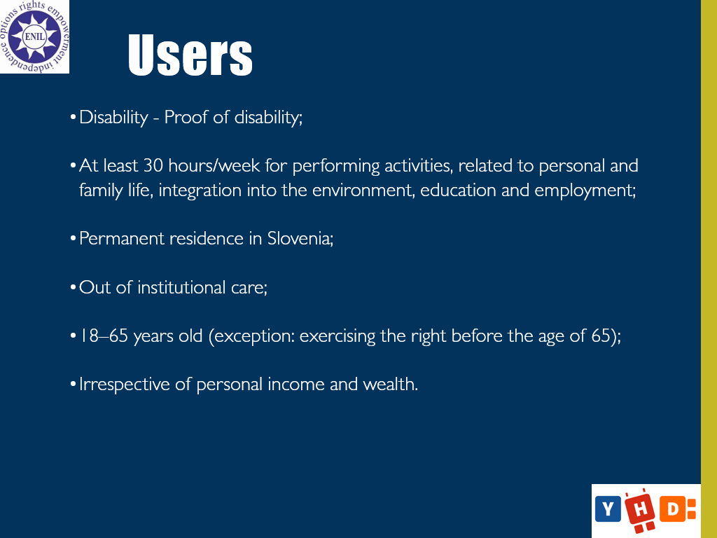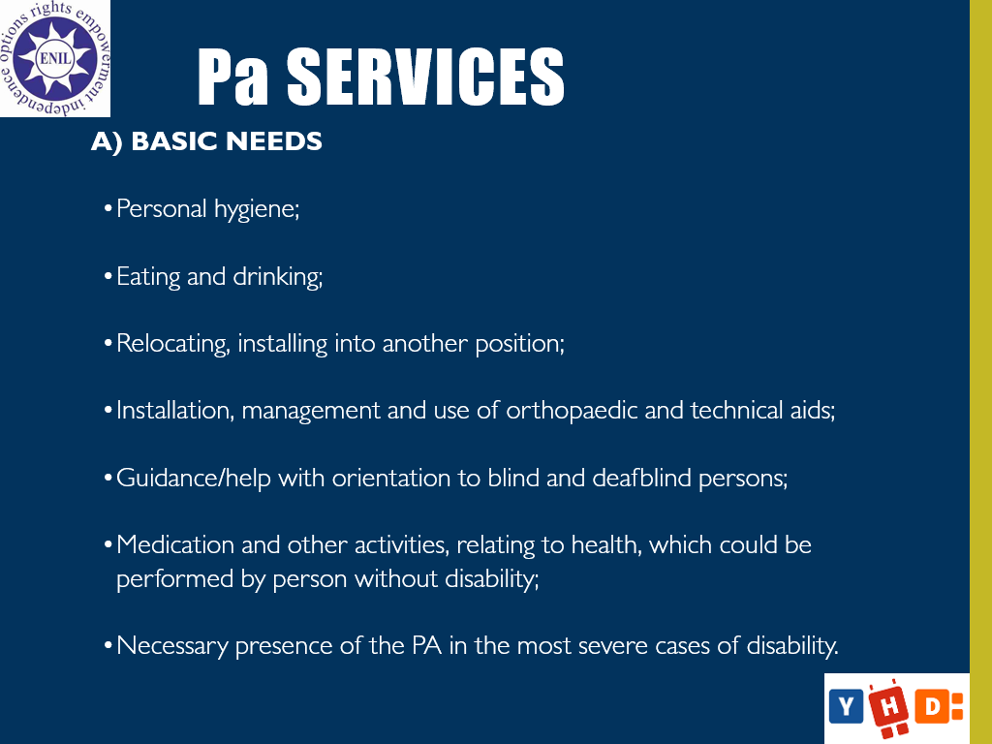
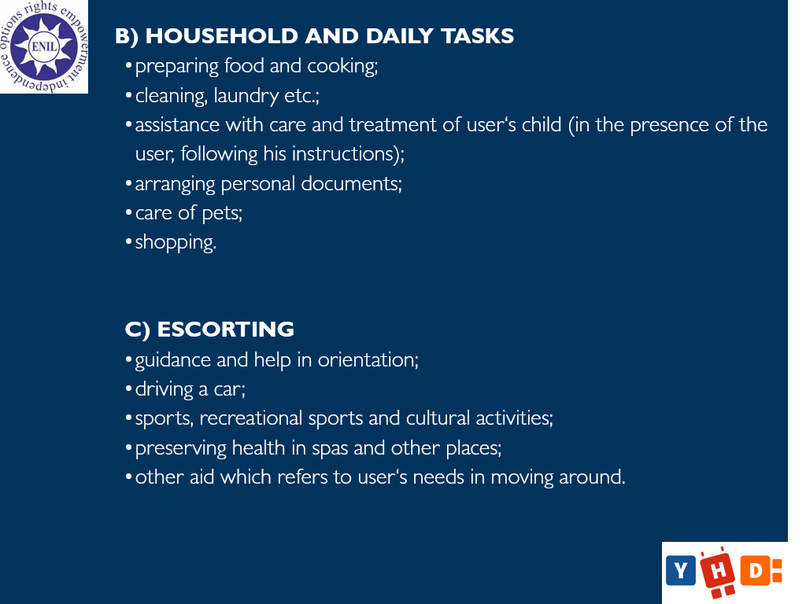
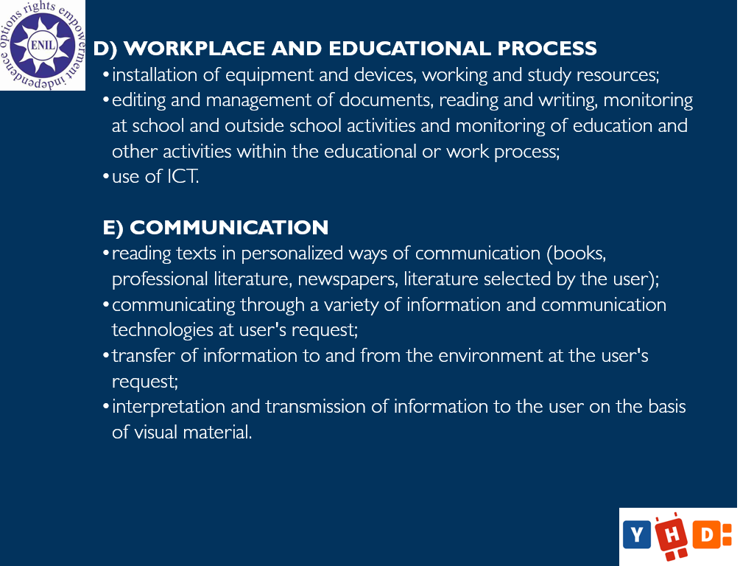

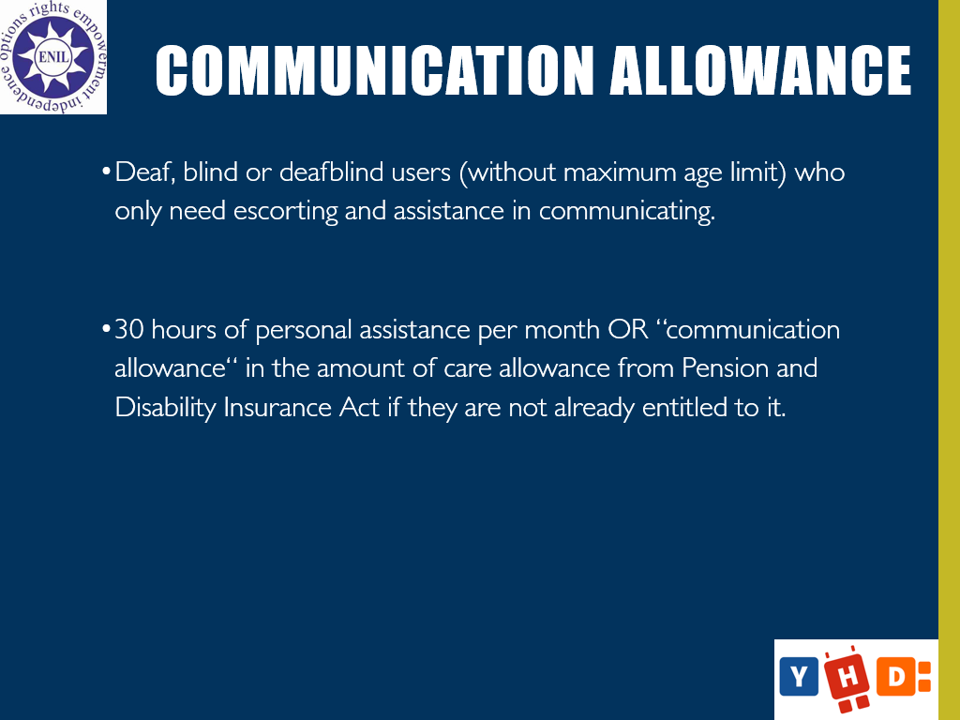
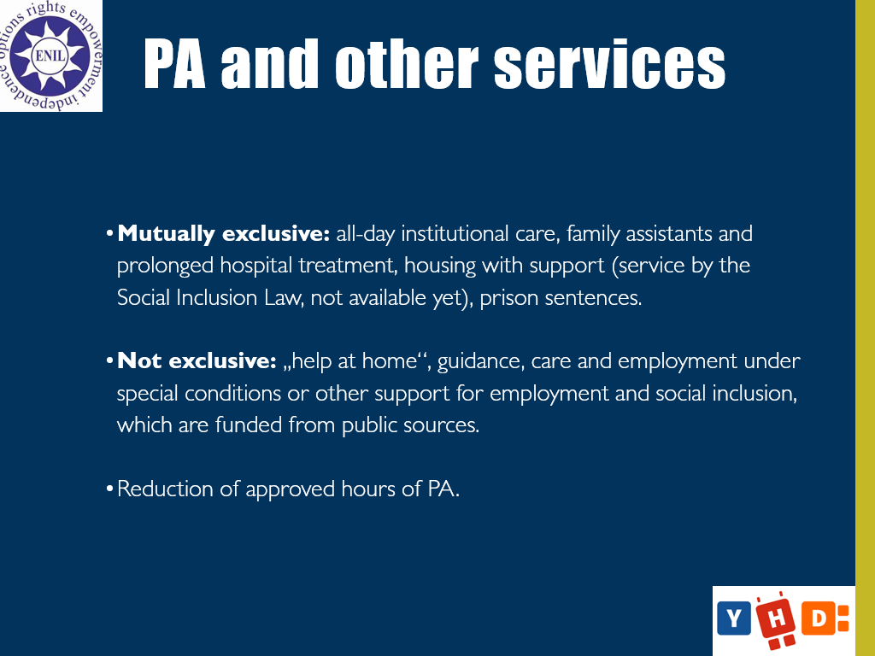
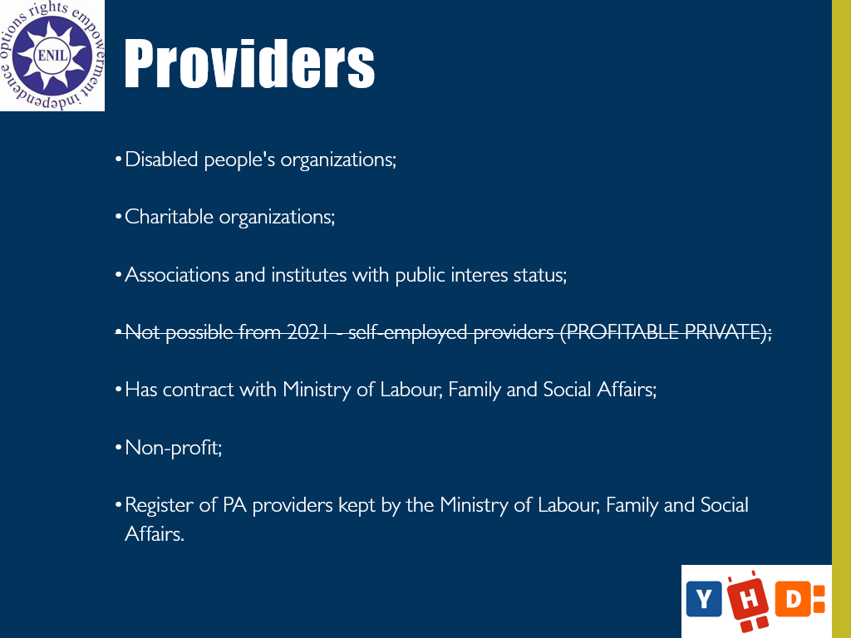
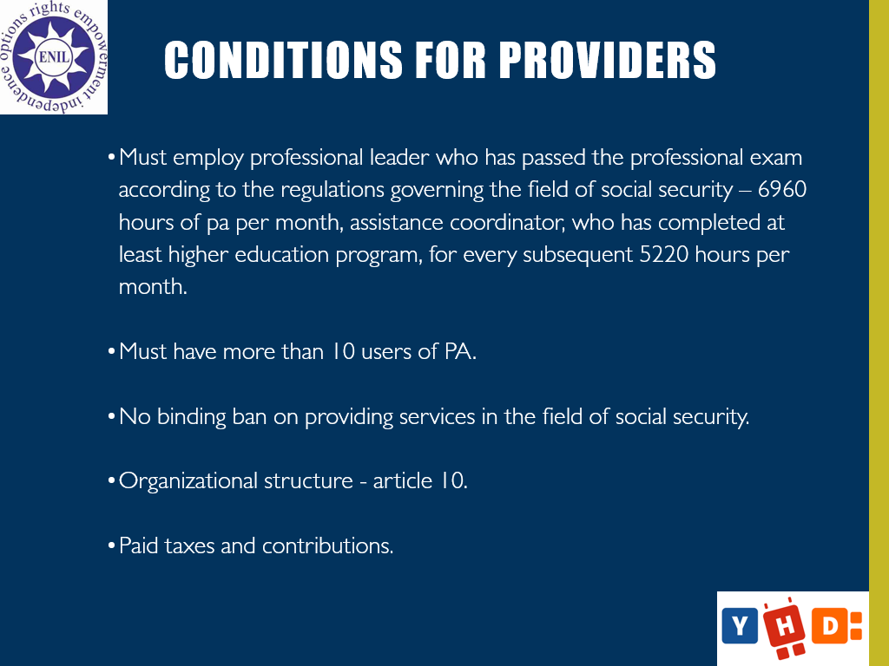
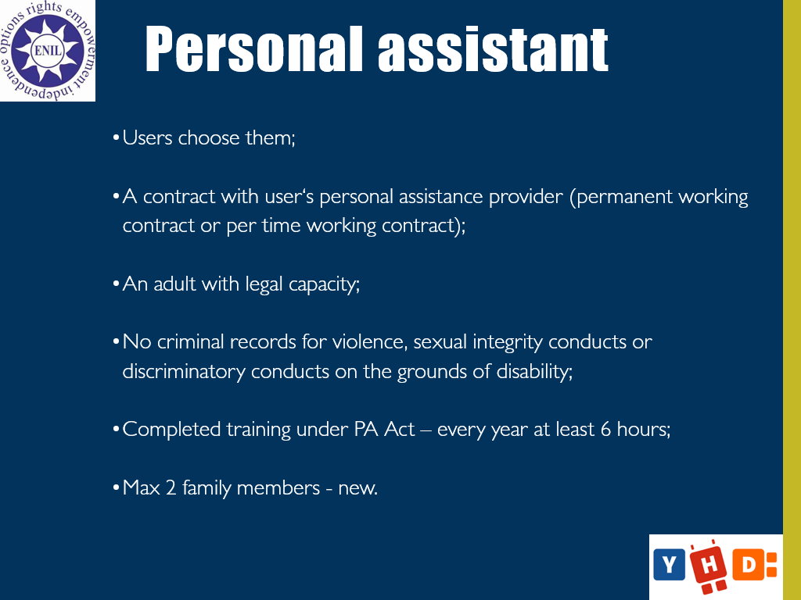
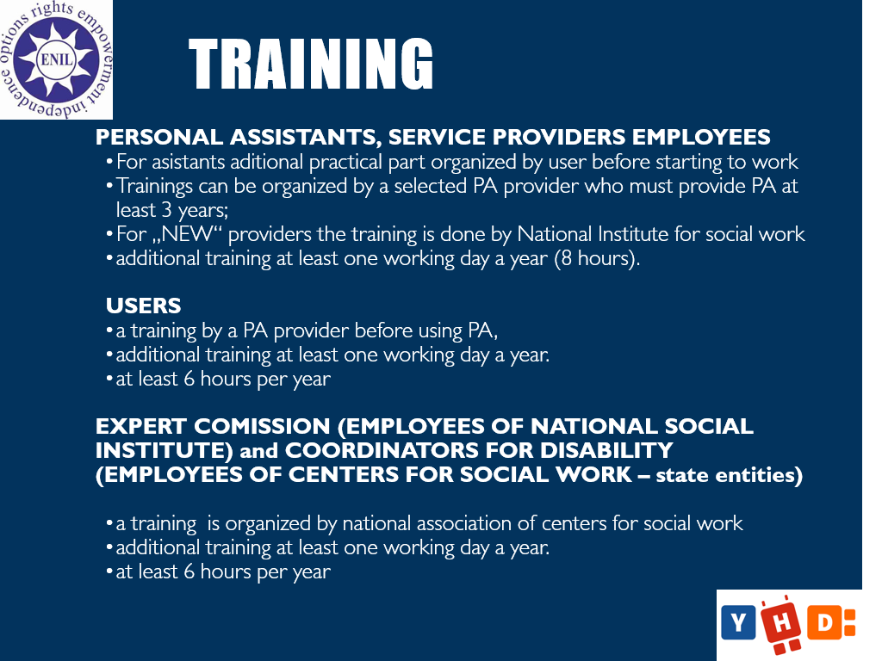
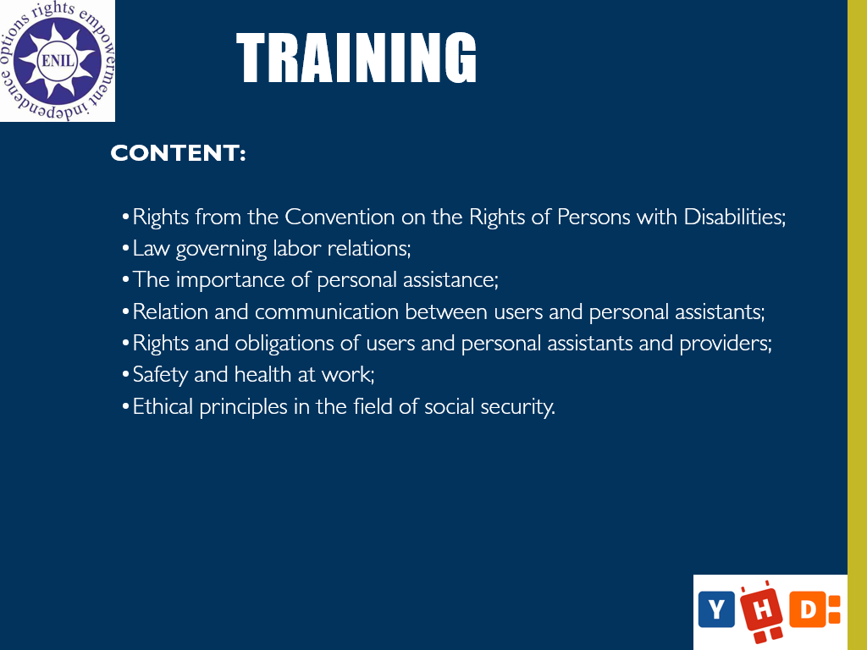
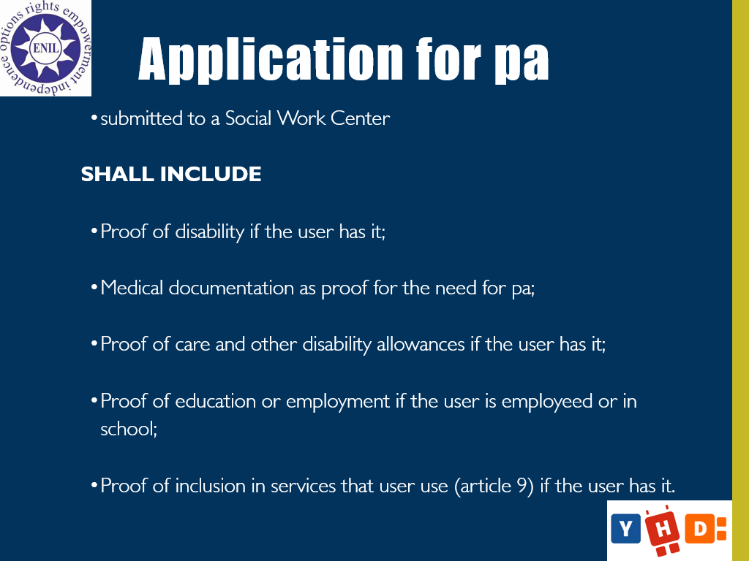
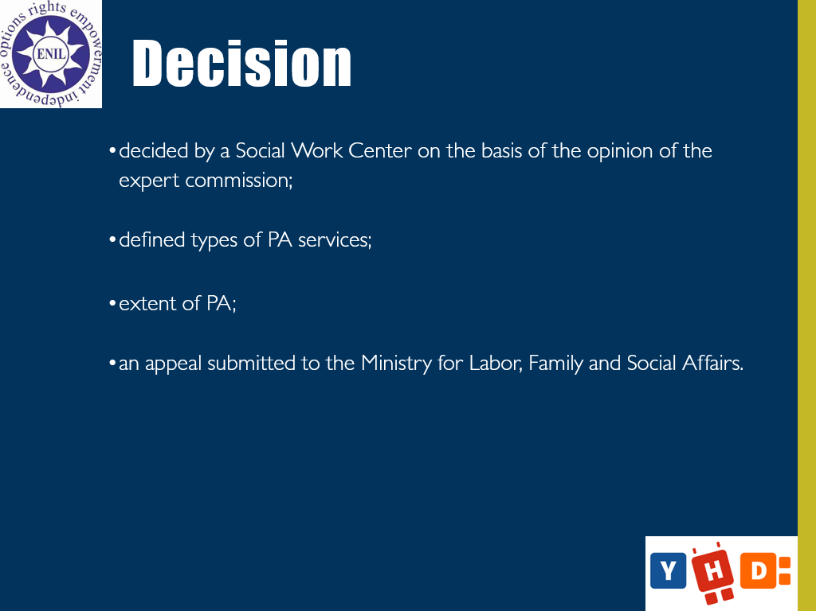
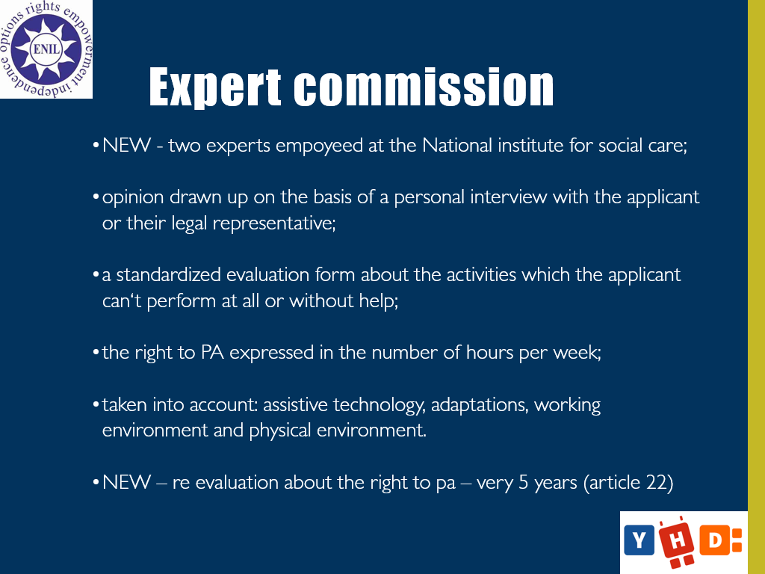
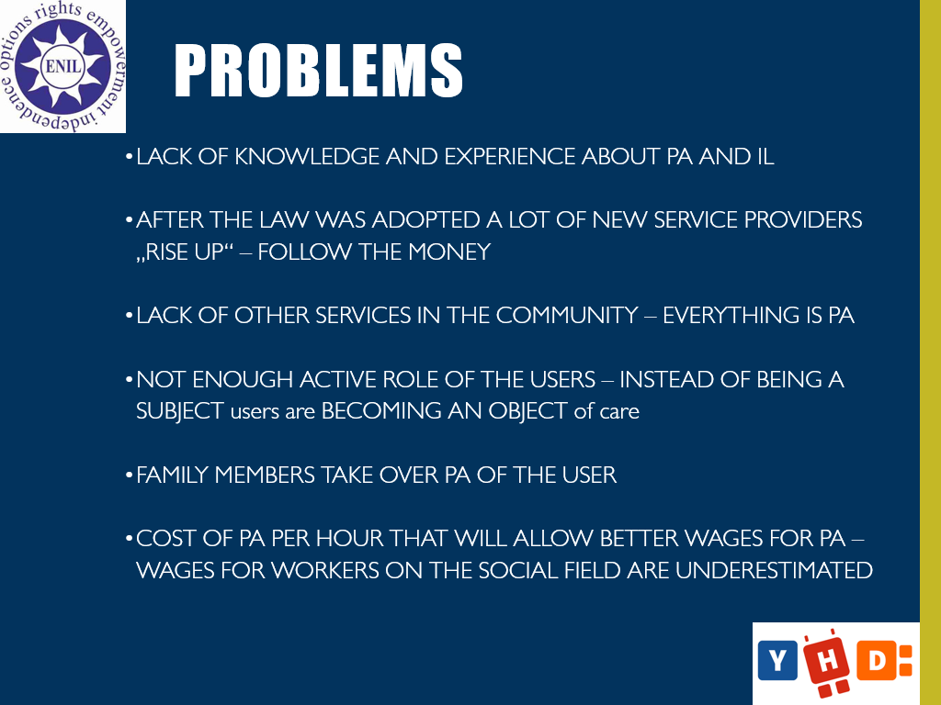
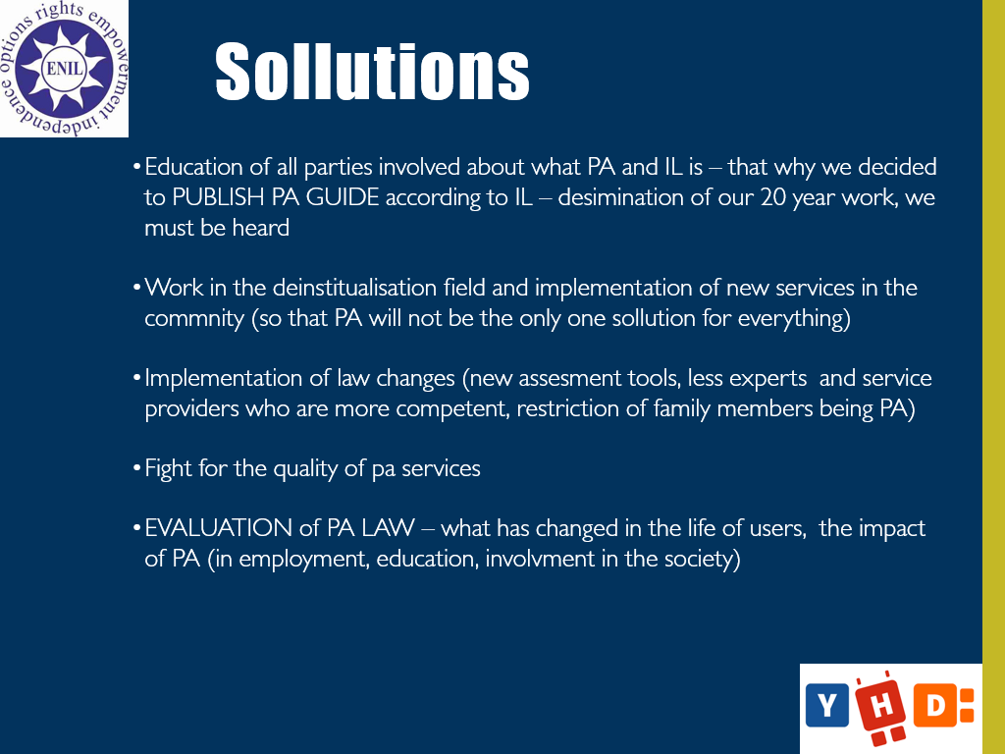

Annex 2 - Presentation: ENIL: Affordable and Accessible Housing

